Progress Report: Woodlands & Waters—Three Tiers of Stakeholder Engagement in the Heart of the Great Lakes

PROGRESS
1. Please summarize your progress on the activities listed in the project work plan or scope section of your proposal since it began or since your last reporting period.
The following activities are divided based on the three tiered education approach of K-12 students, adult citizens, and Michigan leaders.
K-12 Students
Vanderbilt Schools has signed a partnership agreement with Huron Pines and the Northeast Michigan Great Lakes Stewardship Initiative (NEMIGLSI) to implement Place-Based Stewardship Education (PBSE) programs across all grades and subjects. This agreement has led to several projects in the spring 2017 semester including the Earth Day Bag Project which engaged a local grocery store and allowed the students to educate the community on the impacts of single use plastics. Also, high school students collected data that will be used to write a Forest Stewardship Plan for the school forest. Vanderbilt students also participated in a schoolyard BioBlitz and will be making this a yearly event. In August 2017, Huron Pines will be hosting a meeting with inland school districts to discuss PBSE in the coming years and encourage administrative buy in to the program. In September 2017, Tip of the Mitt Watershed Council and Huron Pines will be facilitating a riparian planting with Wolverine Schools that connects to a watershed education program.
Adult Citizens
Huron Pines has taken a leadership role with the Gaylord community BioBlitz which utilizes the citizen science platform iNaturalist; July 2017 will be the third year of involvement in this event. The Cheboygan green belt project is an effort to educate shoreline property owners on the importance of buffer plants and provide opportunity for participating in a cost share program to install green belts. Landowners have purchased kits and have planted native vegetation on their property. Huron Pines reached out to a local excavation company to partner with them on local projects that affect their work and ours. M&M Excavating volunteered their time at the May 2016 Jack Pine Planting Day and learned about the importance of Jack Pine ecosystems to our area. An equipment decontamination training was held with M & M employees to educate them on the importance of cleaning equipment to prevent the spread of invasive species. Twenty stewardship stories have been written to share the impact of partnership on conservation. These have been shared with the public and partner organizations.
Michigan Leaders
Huron Pines led a meeting of stakeholders to give input on the Michigan Statewide Comprehensive Outdoor Recreation Plan in May 2017. At the May 2016 AmeriCorps Signature Service Project, Huron Pines hosted a leadership tour for 13 local and state decision makers in the Pigeon River Country State Forest and facilitated a discussion on natural resources. In conjunction with the 2017 Kirtland’s Warbler Festival, Huron Pines hosted a leadership tour for 14 local decision makers to discuss the management of the species and how the species impacts the economy and communities. The Kirtland’s Warbler Alliance, under the direction of Huron Pines, has reached community leaders and decision makers through events such as Jack Pine Planting Day and education days. Huron Pines led a stakeholders meeting in Presque Isle County to discuss the connection between natural resource conservation and quality of life; several action items came out of that meeting including a commitment to continue the conversation at Team Rogers City meetings. Huron Pines helps lead the Rifle River Prosperity Network which recently implemented a community grants program and is funding a rain garden project at a local school; the leaders of this group have come together to make meaningful changes in their community.

2. Have you made any significant changes to your timeline, approach, budget, or project partners? If so, what are the changes and the reasons for those changes? (Note: If the answer to this question is “yes,” and you are significantly deviating from the scope of work, timeline, and/or budget proposed to and approved by the GLFT, your GLFT grant manager will need to consider these changes before further work can proceed. Please visit the FAQs page online under the Grants tab for further guidance.
No significant changes have been made to this project.

3. For those outcomes where you are not progressing at the anticipated rate, what factors have you identified that are preventing you from doing so?
Recruiting six schools to participate in the PBSE programs has not progressed as anticipated. We have reached out to several schools to arrange initial meetings with administrators and teachers but the interest level is not as high as expected. At the August 2017 meeting of inland school districts, we hope to connect with more administrators to discuss implementing PBSE programs at the schools.

4. Do you currently expect that the planned results will be achieved by the completion of this grant period? If not, please explain.
The planned results of this project are expected to be achieved by the completion of this grant period.

5. If you had an evaluation plan (as part of your original proposal), how are you progressing?
An outside evaluator is under contract to begin evaluation in Fall 2017.

REFLECTIONS
6. Describe any lessons learned or unanticipated benefits, challenges, or surprises you have experienced.
K-12 Students
A challenge has been the school buy in of the PBSE programs; they are excited to have someone come in and do “one and done” programming for the students but the integration of programs into the school culture has not come easily. The partnership with Wolverine Schools has been an unexpected benefit; the lead teacher approached Huron Pines about helping her get the school greenhouse restarted and from there has taken the project and run. The willingness from the school, Tip of the Mitt, and Huron Pines to equally contribute has made this project work seamlessly.
Michigan leaders
A leadership tour as part of the 2017 AmeriCorps Signature Service Project did not happen because of scheduling; many leaders were unable to attend due to the budget discussions happening at all levels of government at the time. In general, when leadership events happen, we have found that leaders come out for the meeting and have productive discussions but when it comes to making an action plan it is difficult to move forward on specific details/action items.

7. Using your proposal as a reference document, what is your vision of the work that you’ll be doing during the remainder of the project? What are the most important issues, challenges, and opportunities you will address?
We will continue to work with Vanderbilt Schools to engage students in stewardship projects and increase use of the school forest as a teaching tool. A community trail building day is planned for August 2017 so that access to the school forest will be easier for all ages. An opportunity with Vanderbilt Schools is the hiring of a new high school science teacher; the administration will be emphasizing the importance of natural resource education/stewardship projects in the interview process. We will also reach out to school districts to engage them in the education programs. The challenge with this will be related to teacher time and buy in for implementing the projects. We will continue to help lead community meetings and host volunteer events for adults.

8. Have you secured any additional funding to support this effort? If so, please describe.
Huron Pines was granted $2500 from the Otsego County Community Foundation for the Vanderbilt Schools project; this grant will be used to develop trails within the school forest and provide professional development for teachers. Huron Pines was granted $30,000/year for 3 years from the Dow Foundation to build the capacity of the Kirtland’s Warbler Association; this funding will allow the Association to operate independently and continue leadership of the conservation of the species. Huron Pines was granted $60,000/year for 4 years from the Healthy Watershed Consortium; this funding will be used to support programs that educate adults on the connection between healthy bodies and healthy natural resources.

9. Who will have need for, or interest in, the results of the project and what formats and avenues will be most important for communicating with these audiences?
School districts, community groups, recreation groups, and government officials will be interested in the results of this project. Outreach materials will be produced based on the results of the outside evaluator, stewardship projects, and volunteer events. As appropriate, community/stakeholder meetings and trainings will be held to share the results and continue the effort.

Financial Information
10. Please complete the attached financial form (instructions are provided). See Financial Progress Report Form.

11. Do you anticipate a need to modify your budget? (Note: The GLFT’s grant policy requires you to submit a budget modification form if there is a change in any expense categories from the approved budget amounts. Please visit the FAQs page online under the Grants tab for further guidance.
The budget will not be modified.

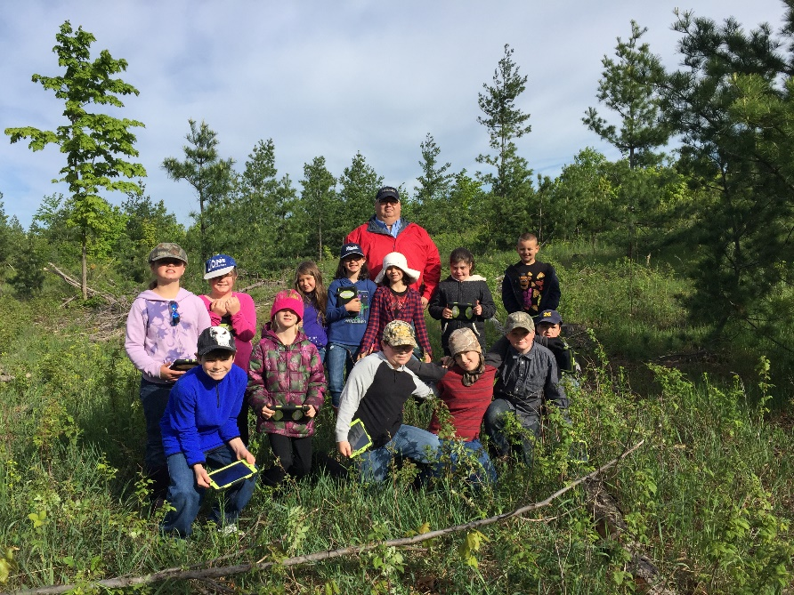
Vanderbilt School students enjoying the backyard BioBlitz they conducted in their school forest.

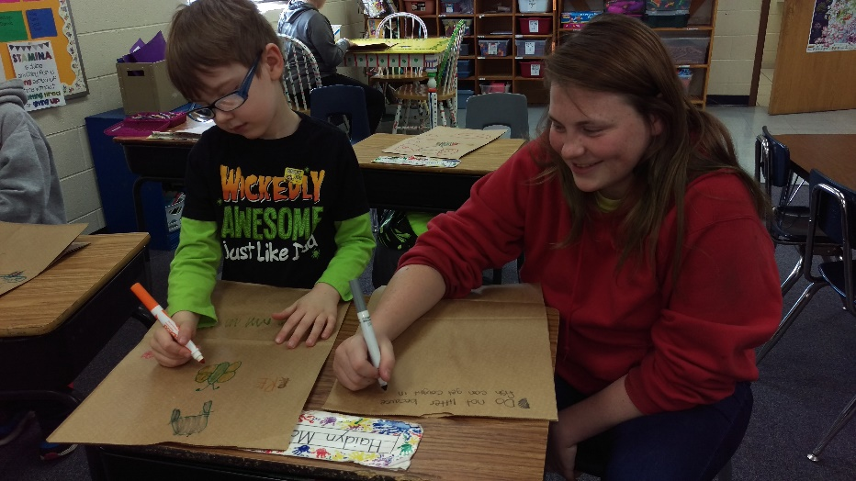
Vanderbilt School students learning about single use plastics and participating in the Earth Day Bag Project.

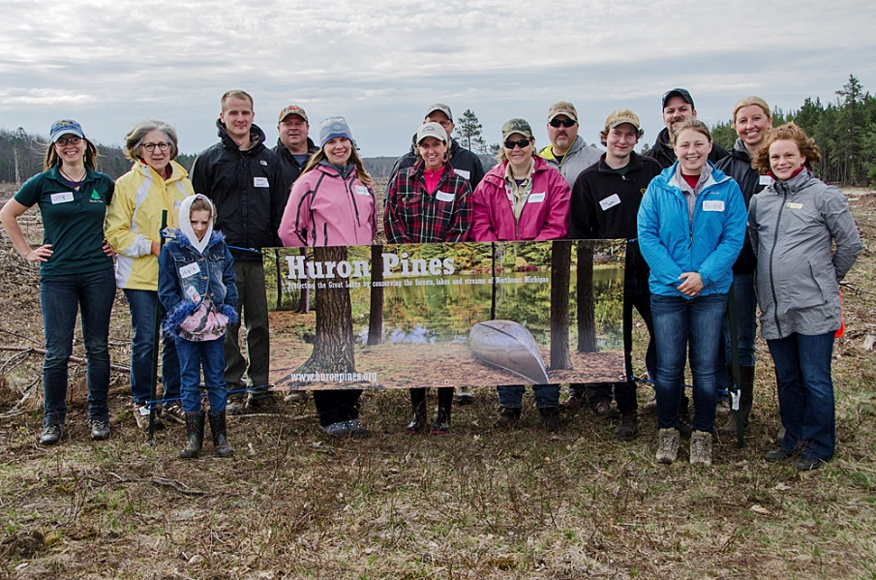
M&M Excavating employees join Huron Pines staff for the 2016 Jack Pine Planting Day.

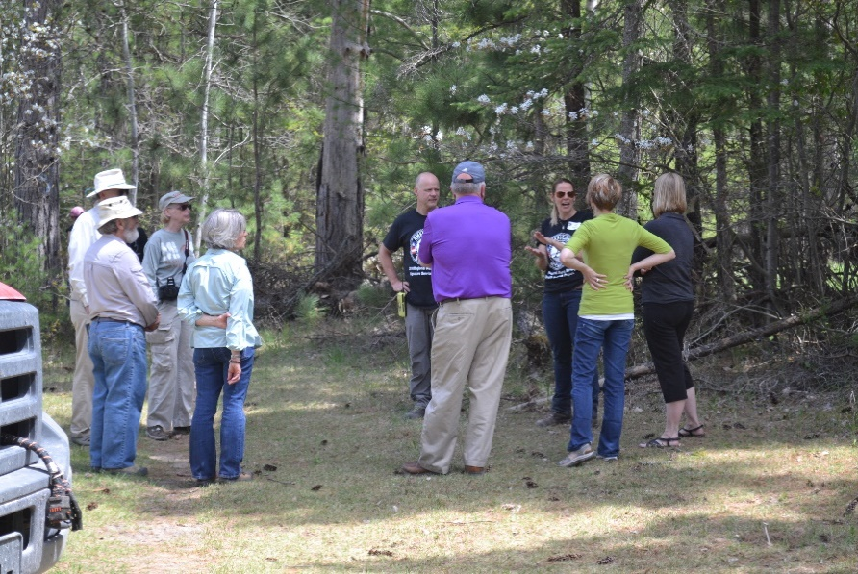
Local leaders enjoyed a walking tour of the Pigeon River State Forest as part of the May 2016 AmeriCorps Signature Service Project.

