FINAL NARRATIVE REPORT GUIDELINES

For each question below be as explicit as possible. The GLFT uses this information for internal evaluation purposes as well as directing the public to the access site (via the GLFT online angler access guide: http://www.glft.org/angleracc.htm).
- Describe the access structure (i.e., length, width, location, design, etc.).
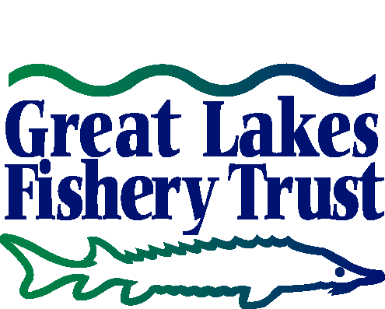
The primary floating fishing pier access onto the lake is 44 feet long and 8 feet wide ending at a “T” floating section perpendicular to primary access section. The “T” section is approximately 48 feet long and 10 feet wide and located near to the under water shelf system where fish habitat is desirable.
- How do visitors access the structure (i.e., driving directions to the parking lot, how far is the structure from the parking lot, what connects the parking lot to the structure, etc.)?
The pier is located Ft. Wilkin’s Historic State Park’s Lake Fanny Hooe boat launch, where there is a paved parking lot and accessible concrete walkway connecting to the fishing pier. From the parking areas to the fishing pier is approximately 75 feet. The pier is also near the park’s western campground, making access easy for campers and is connected by a hard packed gravel trail surface. The project will produce a fully accessible pier, which will be situated close to a natural reef where catching fish is highly likely.
- What amenities are offered at the access site (e.g., restrooms, benches, barrier free access, handicapped parking, lighting, etc.)?
Amenities include a barrier free picnic site with picnic table and grill, interpretative panels that discuss the lake fishery and its connection with Lake Superior, the fish species, and related information. An accessible vault toilet is available at the site and is less than 100 feet from the fishing pier. An accessible bench is also available.
- What educational opportunities are offered at the site (e.g., interpretative signs), if any?
The primary interpretive panel at the fishing pier entry/ exit point is available and includes information as described above. In addition, panels are located on the fishing pier that describe the fish species that can be found in Lake Fanny Hooe, what water depths they frequent with tips on how you may fish for them. All panels on site are attached.
- What species of fish are commonly caught at the site? What months of the year is fishing best for each species?
The lake is in transition of with fishing stocking however, Splake, Brook Trout, Perch, Bass, Pumpkin Seed are all common caught at Lake Fanny Hooe and are available year round during non regulated seasons.
- Does the DNR regularly stock any fish species at or near the site? If so, what species, at what time of year, and how often?
See attached interpretive panel for fishing stocking species and species transition information.

- What tactics do you recommend for catching these species (e.g., small bags, bottom casting, minnows, wobbling plugs, Hot ‘n Tots, etc.).
See attached interpretive panels for recommendations on fish catching suggestions by species.

- Where can anglers stay if they want to overnight near the access site (e.g. campgrounds, motels, hotels, B&Bs)
Fort Wilkins Historic State Park offers two modern campgrounds, a camper cabin adjacent to the fishing site, an organization camping area adjacent to the fishing site and mini cabins within the campground. There are also local motels and facilities in the Village of Copper Harbor which is one mile to the west of the site.
- Is there anything else you would want to share with a potential visitor to the access site?
Contact the Park Headquarters at 906-289-4215 for information on youth fishing programs at the fishing pier and or fishing equipment rental and availability. 15 fish habitat structures were placed on the south side of the fishing pier that should make this site a fun place to catch fish on a regular basis.

