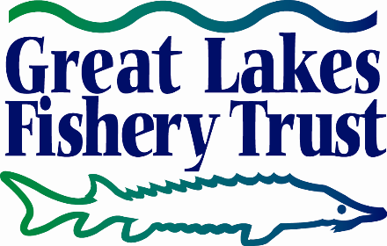

BELLE ISLE SHORELINE FISHING ACCESS IMPROVEMENTS   
Final Narrative Report

Project Profile

Synopsis

* **Project Title:** 2015.1588 Belle Isle Shoreline Fishing Access Improvements
* **Grantee Organization:** Michigan Department of Natural Resources
* **Project Team:** Matt Lincoln, DNR

Amanda Treadwell, DNR

Karis Floyd, DNR

Jim Francis, DNR

Dan Lord, DNR

* **Contact Person**: Amanda Treadwell, DNR treadwella@michigan.gov
* **Grant Amount:** $225,000
* **Time Frame:** December 15, 2015 – October 1, 2019
* **Focus Area:** Detroit River – Belle Isle Park
* **Brief Project Summary**

The purpose of this grant was to renovate the two most popular shoreline fishing areas at Belle Isle Park while improving accessibility for all anglers. More specifically, these areas were equipped with new railings, benches, interpretive signs, access pathways and parking. Once completed, both projects were well received by the public and use has increased substantially.

Project in Context

The DNR has been responsible for Belle Isle Park since 2013. Prior to that time, differed maintenance made many areas of the park unusable, including the two most popular fishing areas at the park. Fishing is a popular activity at the park, however, adequate facilities were not available. The most popular areas lacked proper safety railings and included uneven surfaces which were hazards that made fishing at these locations dangerous. When consulting with the Belle Isle Conservancy, DNR Fisheries Staff and DNR Parks and Recreation Division Staff, all concurred that renovations needed to occur for anglers to safely fish at Belle Isle Park.

The proposed projects were intended to not only renovate the shoreline fishing areas at Belle Isle Park, but were also intended to broaden the population they served by making them universally accessible. This allowed persons of all abilities and ages to enjoy fishing in the Detroit River.

Goals of the Effort

The key goal of the project was to renovate the Oxbow fishing area and the Shelter #9 fishing area at Belle Isle Park to improve safety and accessibility for anglers of all abilities and ages.

Results

The finished projects resulted in new concrete pavement for pathways, new parking lot paving and signage, new railings, interpretive signage and benches. These all resulted in substantial positive feedback over the past summer from anglers and park visitors. An unexpected result was with park visitors that commented on the new facility, even if they had not intended to use the facility. Many visitors walked along the promenade to take in the scenic views of the Detroit River.

Products and Resources

The public outreach was completed in the form of project updates presented at the monthly Belle Isle Park Advisory Committee meetings held for the community.

Final Narrative Report

Background/Overview

The project was completed as originally intended; however, additional coordination and planning was needed to ensure compatibility with the nearby planned Iron Belle Trail. The estimate of probable cost developed prior to seeking funding was also grossly underestimated which resulted in additional fundraising efforts not realized until 2018 which resulted in delay of the Oxbow fishing area construction.

Outcomes

1. The objectives listed in the project narrative were to improve the fishing related amenities listed here; installation of concrete walk to provide ADA accessibility to and along the new accessible railings, Parking lot signage and striping to accommodate barrier free spaces, design of interpretive signs for educational purposes, installation of viewer telescopes, and benches and tackle shelves for anglers. All scope items were realized.

The project was to improve the former unsafe conditions along the sea walls and provide for better ADA accessibility for the greater Detroit community who enjoys fishing on the north and south shore of Belle Isle. The community members provided very positive feedback on the improvements that were made at both sites. The project was an opportunity to strengthen trust between the park management and the community with investment in park infrastructure that is important to users.5. The most important benefits of this project was to be able to invite the public to recreate and appreciate the natural resources available to the community within the City of Detroit.

Site-specific Information

1. The shoreline improvements were completed on the north and south shores of Belle Isle Park. The north shoreline project improved infrastructure along the 500’ seawall, the south seawall is approximately 400’ long. Both projects included new ADA accessible rails and ADA access to and along the seawalls to provide an improved fishing experience for public of all abilities. The scope of work at each site replaced concrete with 10-foot wide concrete along the length of the seawalls. Drainage inlets and lines were replaced to match the new concrete grades and the adjacent lawn areas were graded and reseeded along the new shoreline area and pathways. New ADA accessible fishing rails were installed along the seawalls that replaced the former rails which were not ADA compliant and much of it was in deteriorated condition or not existent. Asphalt ADA parking areas were created adjacent to the pathways and benches were installed as well to provide comfortable viewing area and resting points.
2. The following are answers to questions provided in the original final report template.
3. Visitors access each site by taking the MacArthur Bridge over the Detroit River to Belle Isle. From there, they follow the one-way perimeter road until they reach the parking lots which are located on the right-hand side of the road. The structures for each the north and south shoreline sites area accessible via an ADA accessible walkway from the parking lot. Both fishing areas are visible from the parking lot.
4. Each site provides the following items listed here; benches, barrier-free access, parking and fishing rails, and tackle-shelves attached to the railing system. Each site is also within walking distance from a restroom facility.
5. Fish ID educational signs have been designed and will be installed at the sites once they are fabricated.
6. There is potential to catch rock bass, largemouth bass, smallmouth bass, yellow perch and sunfish most months of the year. Northern pike make seasonal movements in and out of the area, coming in nearshore during late winter- spring and late fall. There could also be the occasional muskellunge in these areas, as shown by Fisheries surveys, particularly in spring. White bass, the species with the highest catch and harvest during MDNR 2015 Detroit River creel survey, make a large run up the river in late spring to early summer. Walleye were highly targeted during the 2015 Detroit River Creel survey as well and make a substantial run up the river but in early to mid-spring.
7. Lake St. Clair, Detroit River and Lake Erie have incredible self-sustaining populations of all the major sport fish and neither Michigan nor Canada stocks these waters. The only exception is steelhead in some tributaries and lake trout by some of the other Lake Erie states. The genetics of the walleye and muskellunge in these waters is too prized to consider stocking, and it simply is not needed. These are the most productive fishing waters in Michigan and for some species, in the country.

Michigan DNR does stock channel catfish on an inland lake on Belle Isle, Lake Muskoday. These fish are stocked every 2 – 3 years in late summer when large fingerlings (> 8 inches) are available from Ohio.

1. Fishing tactics here require a hook, line and sinker approach. The optimal bait for these locations would be minnows and worms. Emerald shiners are the most popular live bait choice for targeting most species, but spottails or fatheads can work as well. Many fishing for white bass or walleye prefer to use a blade bait or a round head jig with small curly tail plastics, but casting with a wide variety of lures (i.e. crankbaits and spoons) will bring luck. Tackle and gear for muskellunge and large pike would need to be more specialized in order to handle these larger species.
2. There are a variety of hotels and levels of service in the city of Detroit that are convenient to Belle Isle Park.
3. Not only are these locations great for fishing, but they are also great locations to view boating activity on the Detroit River.
4. All of the objectives listed above in Outcomes, #2 above were met.

Pictures

1. Provide at least three photos of the completed project.

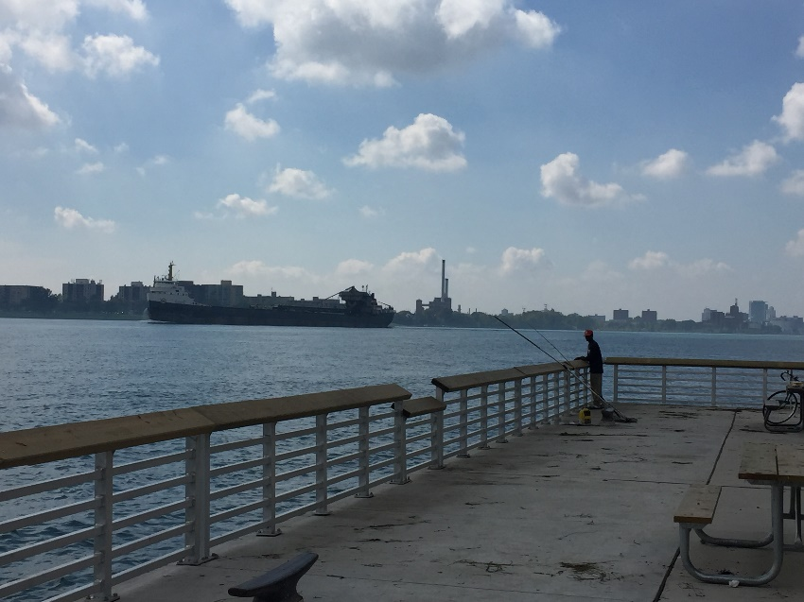

**SOUTH SHORELINE**

**LOOKING WEST**

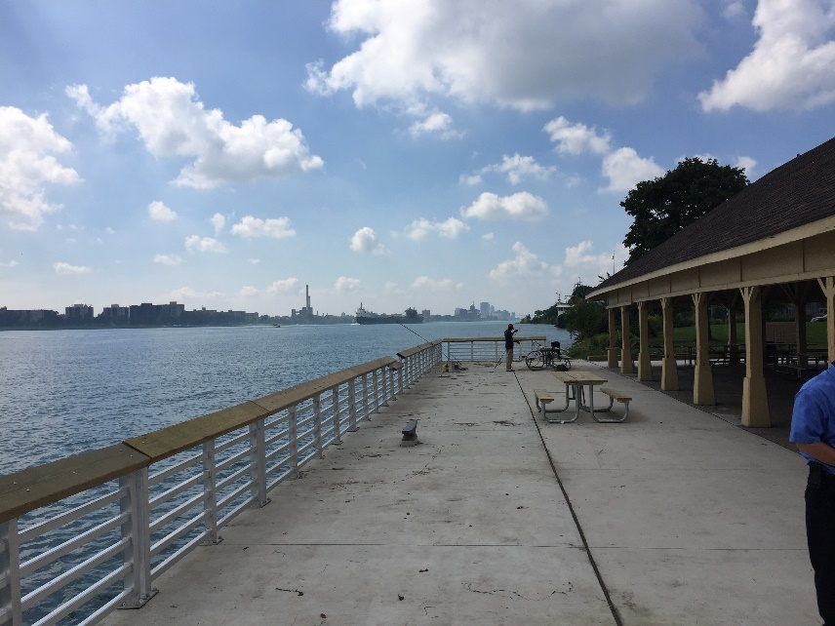

**SOUTH SHORELINE**

**LOOKING WEST**

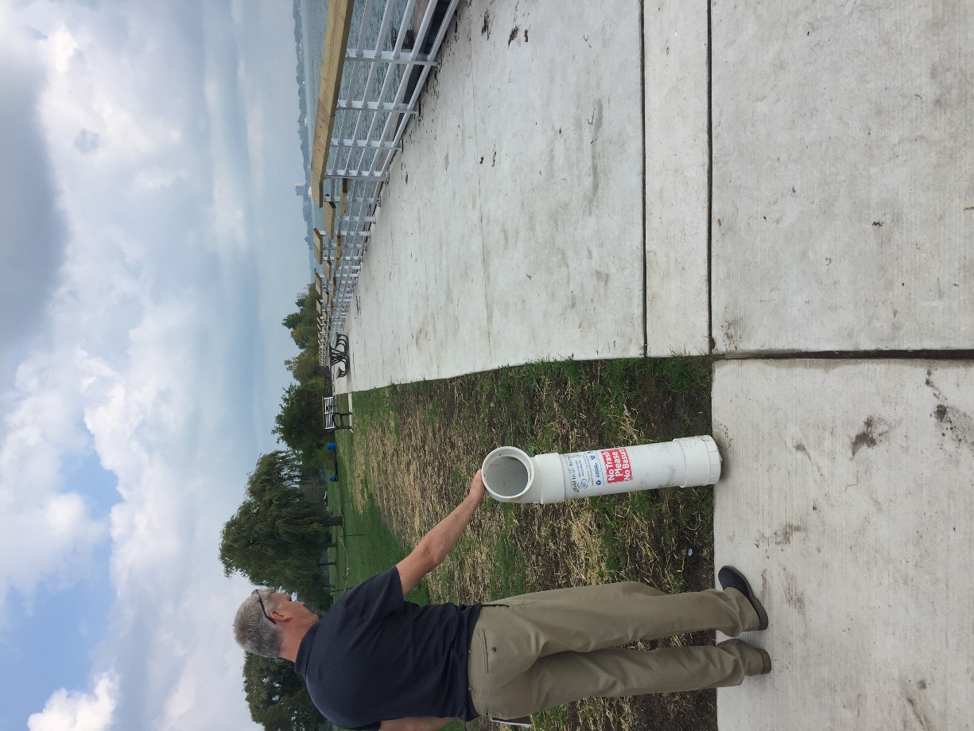

**SOUTH SHORELINE**

**LOOKING EAST**

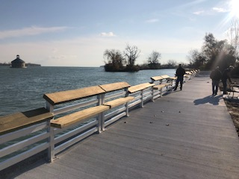

**NORTH SHORELINE**

**LOOKING EAST**

1. Refer to the photo below showing the GLFT plaque mounted on the new railing

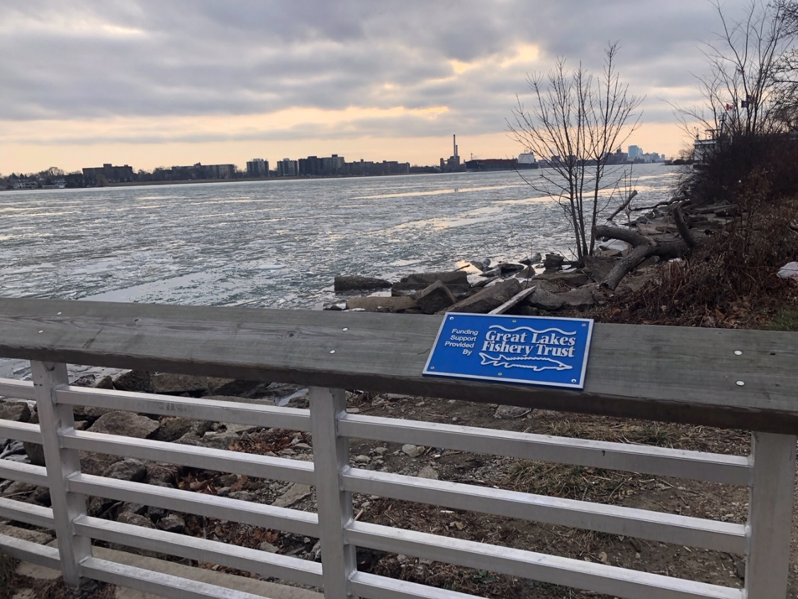

Related Efforts

1. This effort to replace the fishing areas on both the south and north shore was supplemented by DNR Parks and Recreation Division’s Fiscal Year 2018 Capital Outlay funding as well as a Michigan Natural Resources Trust Fund Grant for $300,000.
2. Follow-up work includes the construction of a park trail that loops around the island in 2020. This work will connect park visitors to attractions around the island including the two new fishing areas completed here in the scope of this project. In the future, DNR-PRD is looking to fund improvements to the south fishing pier that is located adjacent to the Friends of Detroit River Lake Okonoka Habitat Restoration project.

Reflections

1. The largest obstacle to completing this project was the underestimated need to fund the scope of work. The project team was able to reevaluate expected project costs for the second phase (North shoreline) that were aligned with the current construction bidding climate.
2. The project team, as well as the public, was very satisfied with the railing product used for both projects (Gator Dock). The Railing was a cost-effective option that was aesthetically pleasing, made of durable materials and provided the ADA accessibility amenities required of the project. The DNR recommends using this product for future shoreline fishing access projects.