Principal investigator
Kevin Pangle
Central Michigan University
Department of Biology
Bioscience Building 2406
Mt. Pleasant, MI 48859
Phone: 989-774-3185
Email: pangl1k@cmich.edu
Collaborators
Jory Jonas
Fisheries Research Biologist
Michigan Department of Natural Resources
Charlevoix Fisheries Research Station

Nicole Watson, Steven Hummel, and Carson Prichard
Graduate Assistants
Central Michigan University
Department of Biology

James Student
Director of Elemental and Isotopic Analysis Labs
Central Michigan University
Department of Earth and Atmospheric Science

Title
Project 2013.1298: Identification of the natal origin of Lake Michigan steelhead using otolith chemistry

Duration of project
11/18/13 – 12/31/16

Amount of project
$196,083.82

Abstract
Our study explored the use of otolith microchemistry as a natural marker for determining natal tributary origins of Lake Michigan steelhead (Oncorhynchus mykiss). Our specific objectives were to: 1) test our ability to differentiate hatchery vs. naturally produced steelhead based on otolith chemistry, 2) test our ability to classify origin at different spatial scales by considering differences between regions, 3) evaluate how classification accuracy may be affected by inter-annual variation in otolith chemistry, 4) compare classification accuracy using the otolith chemistry of age-0 vs. age-1 steelhead, and 5) evaluate the relationships between otolith chemistry and stream water chemistry. To address these objectives, we analyzed the otolith chemistry of juvenile steelhead collected over a four-year period (2012-2015) from 34 Lake Michigan tributaries and 5 different hatcheries. Laser ablation sector-field inductively coupled plasma-mass spectrometry (LA-SF-ICP-MS) was used to determine trace element concentrations (Mg, Mn, Cu, Zn, Sr, Ba, and Pb) along edge-to-core transects of the otoliths. Our results showed that distinct trace element signatures were able to differentiate the natal origin of Lake Michigan steelhead, with the relative accuracy being influenced by spatial resolution and temporal variation. We were able to differentiate hatchery vs. natural origin in 19 stocked streams at a mean accuracy of greater than 95%. For naturally produced fish, our mean accuracy at correctly classifying fish to their specific collection site (i.e., our finest spatial resolution) ranged between 75% and 83%, depending on year, with several sites exhibiting 100% accuracy. Sites that had several misclassifications were often classifying fish to streams that were within close spatial proximity of the correct stream. Indeed, when broadening geographic spatial resolution of our classification, accuracy increased up to 93.5%. Classification of one year-class based on signatures developed from another year-class significant reduced accuracy, demonstrating the importance of inter-annual variation in otolith chemistry signatures. Classification accuracy also was consistently higher for age-0 steelhead vs. age-1 steelhead, with the former age group requiring significantly less effort to collect from streams. Finally, concentrations of strontium, the most important trace element for differentiating natal origin, were strongly correlated between otolith chemistry and stream water chemistry. Overall, our findings demonstrate the ability to use naturally occurring, trace element otolith signatures to differentiate natal tributaries of Lake Michigan steelhead at fine and coarse geographic resolutions. Further, this research provides a strong foundation for future studies to determine the natal origins of adult steelhead, benefiting the management of this species in Lake Michigan and tributaries.

Executive summary
Steelhead (Oncorhynchus mykiss) are economically and ecologically important to the Laurentian Great Lakes, and specifically to the Lake Michigan ecosystem and its watershed (Talheim 1987). Introduced in the late 1800s, Great Lakes steelhead populations have undergone naturalization, with a substantial portion of steelhead production now coming from natural reproduction (Seelbach and Whelan 1988, Rand et al. 1993). In Lake Michigan, natural reproduction is common in many tributaries, particularly those in the state of Michigan, where suitable habitat for spawning and juvenile development is present (Seelbach and Whelan 1988, Seelbach 1993, Newcomb and Coon 1997, Godby et al. 2007). Based on this spatial partitioning of reproduction and development, Lake Michigan steelhead form distinct tributary-specific stocks, with stocks mixing once fish immigrate to the lake as smolts.
The potential of each tributary to contribute to the mixed, open-lake population is likely highly variable due to spatial variation in environmental factors (e.g., thermal regime, substrate type, food resources) that are important to steelhead growth and survival (Newcomb and Coon 1997, Woldt and Rutherford 2002, Godby et al. 2007). From a fisheries perspective, an understanding of the relative contribution of different Lake Michigan tributaries to the Lake Michigan steelhead fishery is critical to managing this species in that it may i) lead to more accurate predictions of the lake population dynamics, ii) identify tributaries producing above or below expectations, and iii) allow quantification of the effects of intentional and unintentional tributary modifications (e.g., habitat improvement, changes to thermal regimes) on steelhead production to the lake fishery (i.e., changes in contribution over time).
Our project goal was to develop an approach that uses the chemical signature found in the otoliths of steelhead to track individuals back to their natal origin. Because otoliths i) incorporate trace metals into their crystalline matrix at concentrations proportional to their abundance in the environment and ii) do not undergo chemical resorption, their chemical composition can provide a permanent chronological record of the environment(s) in which fish have resided during their lifetime (Secor 1992, Thresher 1999, Campana and Thorrold 2001). Importantly, this mark on the otolith is naturally imprinted on all fish inhabiting a given water body, thus overcoming the impracticalities associated with artificial marking techniques.
We collected naturally-produced fish from throughout the Lake Michigan basin, as well as fish from hatcheries that stock in the basin, and examined several factors that may influence the utility of otolith chemistry in deciphering steelhead natal origin. Section 1 of this report provides the general methods used to collect fish, measure their otolith chemistry, and statistically analyze these data. Section 2 describes a test of our ability to differentiate hatchery vs. naturally produced steelhead based on otolith chemistry. Section 3 describes a test of our ability to classify origin at different spatial resolution. Section 4 describes an evaluation of how classification accuracy may be affected by inter-annual variation in otolith chemistry. Section 5 provides a comparison of classification accuracy using the otolith chemistry of age-0 vs. age-1 steelhead. Section 6 describes the relationships between otolith chemistry and stream water chemistry. Section 7 describes some overall conclusions and implications of this study. Section 8 provides a list of presentations and publications in preparation that are associated with the project. Section 9 provides a list of literature cited.

SECTION 1: GENERAL METHODOLOGY

Study area and collection methods
Steelhead were collected from 34 tributaries over a three-year period (2013-2015) around the Lake Michigan basin using backpack electrofishing (Figure 1.1, Table 1.1). Tributaries were selected that are known producers of wild fish and to represent a variety of geologic landscapes and stream environs which would best represent unique otolith chemical signatures based on water chemistry (Creque et al., 2005; Bataille and Bowen 2012, Hegg et al. 2013, Brennan et al. 2014).
Stream sampling occurred in the early summer (April-June) targeting yearlings and older (YAO) and in the fall (September-October) targeting young-of-year (YOY). Water temperatures were recorded with a digital thermometer in 2014 and with a YSI 6600 V2-4 Multiparameter Water Quality Sonde in 2015. The start and end times for each sampling event were also recorded. A target of twenty steelhead was set for each sampling event. Collected fish were stored in a cooler on ice until reaching the university laboratory where fish were frozen in water to decrease the amount of length and weight shrinkage (Sayers 1987).

Otolith extraction and preparation
Fish were thawed immediately before processing. Each fish was weighed to the nearest tenth of a gram and total length recorded to the nearest mm. In the event that a total length was not obtained due to damage to the caudal fin, the standard length was measured and noted for later conversion using the conversion factor put forth by Carlander (1969). Scale samples were taken from each fish, dorsal of the lateral line and midway between the posterior point of dorsal fin attachment, anterior to the beginning of anal fin attachment (Wright et al. 2014). Scales were placed in a paper lined envelope to dry with the unique ID (combination of serial number and fish number) of the fish recorded on the outside of each envelope. Right and left sagittal otoliths were extracted, rubbed between fingers while wearing a textured nitrile glove to remove excess tissue, placed in a bath of 3% hydrogen peroxide for 30 seconds to remove residual tissue, triple rinsed with reverse osmosis (RO) water, then placed in a sorting tray to dry. Right sagittal otoliths were mounted in Epofix™ cold-setting embedding resin using silicone molds and allowed to dry in a desiccation chamber for 24-48 hours. A PICO 155 Precision Saw was used to cut a 300-400 $µ$m transverse section of the otolith. Transverse sections were chosen over longitudinal due to increased clarity of growth rings. Otolith sections were polished until the core was visible, checked for smoothness and absence of any deep scratches under a microscope, mounted onto an etched petrographic slide using brush on Krazy Glue® brand super glue and imaged using an Olympus BX51 microscope at 10x1 magnification under plain transmitted light, following procedures similar to those described in Boehler et al. (2012).

Otolith chemical analysis
Elemental signatures of right sagittal otoliths were obtained using laser ablation sector field inductively coupled plasma mass spectrometry (LA-SF-ICP-MS) at Central Michigan University’s Center for Elemental and Isotopic Analysis (CELISA). Laser ablation was performed using Photon Analyte 193 nm Excimer laser system in conjunction with a computer operated X-Y-Z sample chamber using methods similar to those found in Ludsin et al. (2006), Hand et al. (2008), and Hummel (2014). Seven elemental concentrations were quantified in our analysis: strontium (Sr), barium (Ba), magnesium (Mg), manganese (Mn), copper (Cu), zinc (Zn) and lead (Pb). Thirty-two separate analytical sessions occurred between March 2015 and April 2016 for a combined total of 1298 otoliths analyzed.
The mounted otoliths were sonicated in ultrapure water (18.2 MΩ·cm) for 7 minutes and stored in an ultraclean laminar flow hood overnight prior to analysis. Pre-ablation cleaning (two laser pulses with an 80$µ$m x 80$µ$m wide square beam) occurred directly prior to each analysis to help remove any potential surface contamination along the transect. National Institute of Standards and Technology (NIST) certified trace element standard glass NIST 612 was ablated for 30-40 seconds to use for trace element quantification in the otoliths. Otoliths were ablated across a linear transect from core to edge at a pulse rate of 8-12 Hz using a circular spot size of 30.0-50.0$µ$m diameter and moving at a nominal rate of 6.0$µ$m/s. At the time of analysis, images of each transect line on the otoliths were taken and the transect lengths were recorded.
Ablated material was subsequently carried from the sample chamber to the Thermo-Finnigan Element 2 SF-ICP-MS unit using helium carrier gas (1.6 ± 0.1 L/min) then mixed with argon makeup gas (1.2 ± 0.15 L/min). Laser and SF-ICP-MS operating parameters were tuned to a ²³²Th/²³⁸U ratio of 1.0 and a ²³²Th/²³²Th¹⁶O ratio of <1.8% at the start of each session based on NIST 612 signal. Laser fluence was estimated to be within 3-6 J/cm³. NIST 612 was analyzed (in blocks of four at the beginning and end of each day and after every 5-10 otoliths or 1.5 hours. NIST 610 and MACS3 (USGS carbonate standard) reference standards were run in blocks of three at the beginning and end of each daily session as internal check standards. Trace element concentrations in the otoliths were determined using the Iolite software (version 2.31) Trace Element Internal Standardization Routine (Woodhead et al. 2007; Hellstrom et al. 2008). Calcium was used as an internal standard at 40 wt % as in stoichiometric calcium carbonate relative to the NIST 612 glass concentration values reported by the GeoReM database of December 2009 (see Jochum et al. 2005). For every sample and standard analysis, 30-50 seconds of carrier/makeup gas (He and Ar) background signal was measured prior to laser ablation analysis for gas background corrections. Raw isotope count rates were utilized to calculate background corrected isotope count rates and isotope/internal standard ratios to determine element concentrations in parts per million (ppm). The data was then converted to text file format for use in R Statistical Software.

Post-ablation transect measurements
All post-ablation otoliths were subsequently imaged using Olympus DP70 digital microscope camera and software with 10x1 magnification under polarized transmitted light with an Olympus BX51 microscope. The start of each transect was marked on the image while under magnification. Measurements were taken using ImageJ image software. The total transect length from start of transect to otolith edge, start of transect to primordia and primordia to otolith edge were measured. Ablation transect measurements were used to determine start and end points of data to be included in analysis.

Aging: Scales
Fish were aged using scales. Scales were placed on a glass microscope slide and viewed under a dissecting microscope equipped with a camera. When necessary, an additional cover slide was placed on top to flatten out the scale for clear viewing. One to three complete scales were selected for each fish based on clarity, imaged and the unique ID recorded as to allow for a blind assignment of age by not knowing the total length or date of collection. Ages were assigned by closely examining the circuli patterns of each scale image. Ages were verified using a two reader system with an experienced and a novice reader. In the event that the two readers did not agree, a second reading was performed by both readers with discussion until agreement was reached.

Statistical analysis
To develop the chemical signatures to be utilized in analysis, the ablation transect measurements were used to determine start and end points of data to be included in analysis. The starting point was set as 50 $µ$m after the core to avoid potential maternal effects on the chemical signature. The end point was set as 50 $µ$m before the edge to avoid potential edge contamination. The portion of the ablation transect from start to edge was then divided into 10% increments for analysis. By incorporating a percent based incremental analysis of the ablation transect unique to each fish we were able to account for temporal and growth variations that may occur between fish and sites.
A random forest (RF) algorithm was used (R package ‘randomForest’) to classify fish to site based upon otolith chemical signatures. RF classifies chemical signatures based on classification and regression trees. Mercier et al. (2011) found RF algorithms to be more powerful than other common statistical approaches for otolith chemical analysis. Trees were constructed using a random subset of the otolith data using bootstrap resampling with replacement (Mercier et al. 2011). Fish not used in during tree construction are then considered the “out of bag” (OOB) individuals and used to test the predictability of the tree. Each tree in the forest casts a vote of the origin of each fish and a final predicted origin is assigned based on the outcome of the majority of the trees (Mercier et al. 2011). Factors used in the algorithm were otolith elemental means and site.

Table 1.1. Site name, abbreviated name, and coordinates. Sites are ordered beginning by Wisconsin, clockwise through Upper Peninsula, ending in southern Michigan.
Site Name | Code | Latitude | Longitude
Sauk Creek | SAUK | 43.38660 | 87.87088
Fischer Creek | FSHR | 43.93655 | 87.73150
Woodard Creek | WOOD | 44.72532 | 87.34354
Hibbards Creek | HIBB | 44.98553 | 87.19178
Days River | DAYS | 45.89499 | 86.99302
Eighteen Mile Creek | 18MI | 46.01523 | 86.69473
Haymeadow Creek | HAYM | 46.02579 | 86.85628
Cut River | CUTR | 46.04514 | 85.12505
Black River | BLCK | 46.13488 | 85.36468
Antrim Creek | ANTM | 45.17245 | 85.37266
Horton Creek | HRTN | 45.28304 | 85.08760
Kids Creek | KIDS | 44.73765 | 85.64593
Acme Creek | ACME | 44.77421 | 85.50195
Medusa Creek | MDSA | 45.31492 | 85.29415
Pine Creek | PINE | 44.24359 | 86.05800
Bear Creek | BEAR | 44.31393 | 86.04812
Little Bear Creek | LBER | 44.43103 | 86.06017
Lemon Creek | LEMN | 44.43227 | 86.01496
Little Betsie River | LBET | 44.53482 | 85.93077
Twin Creek | TWIN | 44.04673 | 85.77512
Little Manistee River | LMAN | 44.11546 | 85.97305
Cool Creek | COOL | 44.16146 | 86.00180
Little South Branch Pere Marquette | LSPM | 43.85024 | 85.84331
Middle Branch Pere Marquette | MBPM | 43.86849 | 85.77471
Sanborn Creek | SNBN | 43.91032 | 85.76215
Weldon Creek | WELD | 43.95365 | 86.15404
Muskegon Small Tributary | MSST | 43.41277 | 85.71722
Bigelow Creek | BGLW | 43.42502 | 85.76892
Honey Creek | HNEY | 42.97160 | 85.48386
Egypt Creek | EGPT | 43.00738 | 85.53088
Prairie Creek | PRRE | 43.01218 | 85.01681
Silver Creek | SLVR | 42.66150 | 85.92860
Unnamed Tributary | UNNM | 41.86142 | 86.24261
Townsend Creek | TWND | 41.93606 | 86.32222
Figure 1.1. Locations of the 34 streams sampled in Michigan and Wisconsin, USA. Site abbreviations are shown corresponding to each stream. See Table 1.1 for full site names, latitude, and longitude.

SECTION 2: DISCRIMINATION OF WILD- AND HATCHERY-ORIGIN LAKE MICHIGAN STEELHEAD BASED ON OTOLITH CHEMISTRY
Introduction
This portion of the study was designed to assess the ability of otolith microchemical analysis to discriminate wild- and hatchery-origin Lake Michigan steelhead. We propose two primary hypotheses:

H1. Among the five hatcheries that contribute juvenile steelhead to the Lake Michigan basin, otolith chemistry can be used to classify juvenile, hatchery-origin steelhead to the correct hatchery of origin.

H2. Within stream-systems into which juvenile steelhead are stocked, otolith chemistry can be used to correctly classify juvenile steelhead as wild- or hatchery-origin.

To test hypothesis 1 (H1), we assessed the ability of a classification model built using otolith microchemistry data to assign fish to the correct hatchery of origin. Otolith microchemistry data for this analysis were obtained from juvenile steelhead sampled at each of the hatcheries that raise steelhead to be stocked within the Lake Michigan basin. To test hypothesis 2 (H2), we assessed the extents to which stream-specific classification models could correctly discriminate between known, wild-origin juvenile steelhead sampled from 25 Lake Michigan tributaries and hatchery-origin juvenile steelhead from the hatcheries that source the stockings into those streams.
While many published otolith chemistry provenance studies have assessed the performance of classification models on known-origin samples, relatively few studies have subsequently applied these predictive models to fish of unknown origin (e.g., Vasconcelos et al. 2008; Engstedt et al. 2010). To demonstrate how such predictive models can be used to determine the natal sources of unknown-origin fish, we applied our stream-specific classification models on unknown-origin YAO steelhead sampled from these same streams to predict their origin (i.e., hatchery vs. wild). Natal source predictions of unknown-origin samples are presented in the context of uncertainty measures derived from each stream-specific model’s performance on known-origin samples. This work provides an example of how classification models built using otolith chemistry data from known-origin fish can be applied to fish of unknown-origin, and demonstrates the applicability of this technique for discriminating hatchery- and wild-origin fishes in the Great Lakes region.

Methods
Sample collection.—Juvenile steelhead collected for this research are described in Tables 2.1 and 2.2. Hatchery sites constituted all of the hatcheries at which steelhead stocked into the Lake Michigan basin between 2014 and 2016 were raised. Stream sites comprised tributaries previously shown to support anadromous salmonid natural reproduction (e.g., Seelbach and Whelan 1988; Rutherford 1997; Hirethota and Burzynski 2015), and were also selected to maximize spatial (Figure 2.1) and geologic representations of the Lake Michigan basin. Hatchery fish were collected by hatchery personnel and stream-caught fish were sampled using backpack electrofishing. All samples were stored frozen in water until lab processing.
In order to appropriately compare time-varying otolith chemistries among fish of different natal origins, data should comprise similar temporal extents within the lives of the fish analyzed. For our classification model development and natal origin predictions, we truncated transects and associated otolith chemistry data relative to the youngest fish (i.e., earliest sampling date) used to develop each model (see calculation of t_{2adj} in Figure 2.2). To do this, we assumed an otolith formation date of April 1, as well as a linear relationship between otolith age and transect length. Additionally, because otolith core chemistries of juvenile anadromous salmonids vary with the spawning run timing of the mother (e.g., Miller and Kent 2009), data included our analyses begin 50 µm outside of the core.

To test H1, the RF algorithm was used to build a classification model to predict the hatchery of origin of juvenile steelhead sampled from the five hatcheries used for Lake Michigan plantings. Fish used to construct the model are those described in Table 2.1. We built a full model consisting of a class target variable, with five levels for each of the hatcheries, and 70 interval input variables corresponding to the decile mean concentrations of the seven measured elements. We assessed the performance of the full model at three levels of m_{try} – the proportion of input variables (p) considered at each tree split within the RF algorithm (see Liaw and Wiener (2002) for a description of the RF terminology used herein). We compared the performance of the full model against a subset of reduced models that contained fewer elements as input variables. Upon examination of the variable importance values (essentially the decrease in model performance absent a particular input variable; Liaw and Wiener (2002)) produced by building the full model, we chose to examine only a subset of the potential reduced models most likely to perform as well or better than the full model. All RF models were run with an n_{tree} value of 200,000. We report all results in terms of misclassification rates.

To test H2, the RF algorithm was used to build 25 site-specific classification models. Individual fish included in each site-specific model consisted of the wild-origin age-0 steelhead sampled from that site (Table 2.2), and hatchery-origin steelhead from the hatcheries that sourced steelhead stocked proximal to that site from 2014 to 2016 (Table 2.1). Fish in this analysis are considered known-origin because the hatchery-origin juvenile steelhead were obtained directly from the hatcheries, and wild-origin juvenile steelhead were obtained as age-0 fish sampled in the fall. We can be confident that age-0 juvenile steelhead sampled in the fall are truly wild-origin because, among the streams included in our analyses, the Indiana, Michigan, and Wisconsin DNRs: (1) only stocked juvenile steelhead as yearlings in the spring, or (2) stocked juvenile steelhead as fall fingerlings later in the season than our collections. Scale ageing was used to verify known, wild-origin juvenile steelhead as age-0. Each model thus consisted of a class target variable whose levels were the potential origins of the fish (i.e., “wild” and any of the hatcheries included in each site-specific model), and the interval input variables from the best-performing model built to test H1. For practical purposes, we report misclassification rates in terms of wild- (W) or hatchery- (H) origin assignment.

According to the RF algorithm, the prediction of each observation represents the level of the target to which an observation classifies most often among all of the classification trees within the model (Breiman 2001). In addition, the fraction of individual classifications, called votes, into each level of the target variable, can be interpreted as the predicted probability for each of the classes (Liaw and Wiener 2002). As additional measures of model performance, we present: (1) the minimum percent votes among all fish for models with 100% classification accuracy, and (2) the maximum percent of votes among misclassified fish for models in which there were misclassifications.

Lastly, we applied these stream-specific classification models to the unknown-origin, age-1 steelhead described in Table 2. To account for uncertainty in the RF model predictions of unknown-origin juvenile steelhead, we deemed predictions corresponding to vote percentages less than those of all misclassified, known-origin juvenile steelhead for a particular site-specific model as insufficient for natal-origin assignment (i.e., “unknown”).

Results
Discrimination among hatcheries.-The RF classification algorithm achieved the lowest misclassification rate (4.41%) when all of the elements were included as input variables and m_{try} = 0.5p^{0.5} (Table 2.3). Of the reduced models explored, models using only Sr and Ba as inputs, or Mn, Sr, and Ba as inputs, achieved misclassification rates of 5.88% at m_{try} values of 0.5p^{0.5} and p^{0.5}, respectively. Elemental concentrations of Sr and Ba showed the greatest contrast among hatcheries across the otolith transects, and this was driven to a large degree by Sr concentrations in excess of 1000 ppm at TSFH (Figure 2.3). All fish from BSFH and TSFH classified to the correct hatchery of origin (Table 2.4), despite apparent incongruences in the concentrations of Sr and Ba between the 2013 and 2015 year classes at BSFH (Figure 3). One fish from each of ILFH and KMFH misclassified into the other, and one WLFH fish misclassified as having come from BSFH (Table 2.4).
Site-specific hatchery vs. wild classification.-Overall, 19 of the 25 site-specific classification models exhibited 0.0% misclassification (Table 2.5). Of the sites stocked by only a single hatchery, only the model for Bigelow Creek had fish that misclassified (10.0%). All of the sites sourced by three hatcheries (i.e., BSFH, TSFH, and WLFH) had fish that misclassified, but improper discrimination between wild- and hatchery-origin never exceeded 3.4% (Table 2.5). In terms of misclassification rate and the predicted probabilities of assignments, the model for Eighteen Mile Creek performed the best with all predicted probabilities of assignment ≥84.3% (Table 2.5). Figure 2.4 shows how the elements most important for discriminating wild- and hatchery-origin juvenile steelhead differed between the Eighteen Mile Creek model (the best-performing model) and the Bigelow Creek model (the poorest performing model).
Natal origin predictions of unknown-origin juvenile steelhead.-We predicted the natal origins of 353 age-1 steelhead of unknown-origin (Table 2.6). The majority (89.5%) were predicted to be of wild origin. Based upon their otolith microchemistries, we detected fish from each of the hatcheries that sourced steelhead stockings into the tributaries that we sampled. Representative otolith chemistry plots of sites within the stocking domains of each possible hatchery that exhibited hatchery-origin assignments are shown in Figure 2.5.

Hatchery description | Abbreviation | Sample date | Year class | n | TL (mm)
Bodine State Fish Hatchery, Mishawaka, IN | BSFH | 10 Apr 2014 | 2013 | 8 | 190 ± 9.2
 |  | 17 Nov 2015 | 2015 | 10 | 157 ± 3.9
Jake Wolf Memorial Fish Hatchery, Topeka, IL | ILFH | 20 Oct 2015 | 2015 | 10 | 175 ± 6.0
Kettle Moraine Springs Hatchery, Adell, WI | KMFH | 1 Nov 2015 | 2015 | 10 | 171 ± 6.1
Thompson State Fish Hatchery, Manistique, MI | TSFH | 25 Apr 2014 | 2013 | 10 | 205 ± 4.7
 |  | 13 Apr 2015 | 2014 | 10 | 190 ± 5.8
Wolf Lake State Fish Hatchery, Mattawan, MI | WLFH | 28 Aug 2015 | 2015 | 10 | 182 ± 4.2
Table 2.1. Sampling information for hatchery-origin juvenile steelhead. Total lengths (TL) are presented with standard errors.

Table 2.2. Sampling information for wild-origin, age-0 juvenile steelhead and wild-captured age-1 juvenile steelhead of unknown origin. Total lengths (TL) are presented ± 1 SE. Fish ages were confirmed by counting scale annuli.
 |  | Known-origin age-0s |  | Unknown-origin age-1s
Site | Sample date | n | TL (mm) | n | TL (mm)
Michigan streams (north to south)
Haymeadow Creek | 18-Jun-14 | 0 |  | 4 | 133 ± 6.1
 | 26-Aug-15 | 10 | 73 ± 1.6 | 10 | 175 ± 5.0
Eighteen Mile Creek | 18-Jun-14 | 0 |  | 7 | 128 ± 5.9
 | 26-Aug-15 | 9 | 70 ± 2.1 | 0
Days River | 26-Aug-15 | 10 | 76 ± 2.3 | 0
Horton Creek | 2-Jul-14 | 0 |  | 10 | 146 ± 6.4
 | 10-Jul-15 | 0 |  | 8 | 152 ± 5.4
 | 5-Nov-15 | 10 | 80 ± 2.8 | 2 | 152.5 ± 6.5
Jordan River | 11-Jul-14 | 0 |  | 8 | 144 ± 5.4
 | 28-Aug-14 | 10 | 62 ± 3.8 | 0
 | 8-Jul-15 | 0 |  | 10 | 162 ± 8.8
Kids Creek | 21-Jun-14 | 0 |  | 10 | 120 ± 5.6
 | 30-Aug-14 | 11 | 61 ± 2.1 | 0
 | 3-Jun-15 | 0 |  | 10 | 109 ± 5.4
 | 24-Aug-15 | 10 | 49 ± 1.5 | 0
Platte River | 3-Jun-15 | 0 |  | 8 | 152 ± 15.8
 | 14-Jul-15 | 10 | 53 ± 2.3 | 2 | 131 ± 25.5
Lemon Creek | 1-Jul-14 | 0 |  | 4 | 157 ± 9.9
 | 9-Sep-15 | 10 | 77 ± 3.2 | 0
Bear Creek | 1-Jul-14 | 0 |  | 10 | 142 ± 5.7
 | 18-Sep-14 | 10 | 75 ± 4.6 | 0
 | 14-Jul-15 | 0 |  | 10 | 144 ± 6.1
 | 18-Oct-15 | 10 | 79 ± 4.4 | 0
Pine Creek | 4-Nov-14 | 12 | 71 ± 4.8 | 4 | 143 ± 26.4
 | 2-Jun-15 | 0 |  | 11 | 105 ± 6.3
 | 18-Oct-15 | 10 | 65 ± 3.8 | 0
Weldon Creek | 30-Jun-14 | 0 |  | 10 | 132 ± 5.1
 | 10-Oct-14 | 9 | 84 ± 2.4 | 0
 | 2-Jun-15 | 0 |  | 10 | 135 ± 6.5
 | 16-Oct-15 | 10 | 66 ± 2.9 | 0
Sanborn Creek | 30-Jun-14 | 0 |  | 5 | 113 ± 9.7
 | 25-Oct-14 | 5 | 68 ± 1.3 | 2 | 126 ± 11.5
 | 14-Jul-15 | 0 |  | 7 | 130 ± 11.0
 | 16-Oct-15 | 10 | 70 ± 2.0 | 3 | 130 ± 2.2
Middle Branch Pere | 25-Oct-14 | 10 | 65 ± 2.0 | 0
Marquette River | 1-Jun-15 | 0 |  | 10 | 108 ± 4.7
 | 16-Oct-15 | 10 | 83 ± 2.2 | 0
Little S Br Pere Marquette | 30-Jun-14 | 0 |  | 5 | 141 ± 4.6
River | 9-Oct-14 | 10 | 80 ± 4.6 | 5 | 144 ± 18.6
 | 1-Jun-15 | 0 |  | 1 | 110 ± NA
 | 14-Jul-15 | 0 |  | 1 | 122 ± NA
 | 16-Oct-15 | 10 | 74 ± 3.5 | 8 | 164 ± 11.5
Bigelow Creek | 24-Jun-14 | 1 | 76 ± NA | 4 | 120 ± 3.6
 | 24-Sep-14 | 9 | 69 ± 3.0 | 5 | 176 ± 3.7
 | 19-May-15 | 0 |  | 10 | 127 ± 11.5
 | 17-Oct-15 | 10 | 77 ± 1.7 | 0
Muskegon River tributary at | 19-May-15 | 0 |  | 10 | 72 ± 1.7
Thornapple boat launch | 17-Oct-15 | 10 | 57 ± 1.5 | 0
Prairie Creek | 24-Jun-14 | 0 |  | 3 | 177 ± 15.7
 | 18-Sep-14 | 7 | 87 ± 4.5 | 3 | 179 ± 22.0
 | 11-May-15 | 0 |  | 3 | 146 ± 13.9
 | 9-Oct-15 | 13 | 87 ± 3.2 | 5 | 200 ± 9.2
Egypt Creek | 9-Oct-15 | 13 | 115 ± 3.5 | 7 | 184 ± 4.9
Honey Creek | 22-Dec-15 | 10 | 91 ± 2.2 | 10 | 168 ± 2.7
Silver Creek | 23-Jun-14 | 0 |  | 10 | 115 ± 5.6
 | 3-Sep-14 | 11 | 65 ± 2.2 | 0
 | 12-May-15 | 0 |  | 10 | 118 ± 7.4
 | 28-Aug-15 | 10 | 49 ± 0.9 | 0
Townsend Creek | 23-Jun-14 | 0 |  | 10 | 140 ± 5.7
 | 3-Sep-14 | 10 | 71 ± 3.0 | 0
 | 14-May-15 | 0 |  | 10 | 132 ± 4.9
 | 28-Aug-15 | 10 | 51 ± 1.9 | 0
Dowagiac River tributary at | 14-May-15 | 0 |  | 10 | 112 ± 4.6
Pucker St dam | 28-Aug-15 | 10 | 64 ± 2.8 | 0
Wisconsin streams (north to south)
Hibbard Creek | 18-Jun-14 | 0 |  | 10 | 157 ± 8.0
 | 2-Sep-14 | 9 | 76 ± 2.8 | 0
 | 9-Jun-15 | 0 |  | 10 | 134 ± 3.9
 | 27-Aug-15 | 10 | 61 ± 1.6 | 0
Fischer Creek | 2-Sep-14 | 3 | 80 ± 4.7 | 10 | 136 ± 6.7
 | 28-Apr-15 | 0 |  | 9 | 129 ± 8.1
 | 27-Aug-15 | 10 | 74 ± 1.7 | 0
Sauk Creek | 3-Sep-14 | 10 | 103 ± 2.7 | 0
 | 29-Apr-15 | 0 |  | 2 | 119 ± 13.5
 | 8-Jun-15 | 0 |  | 8 | 180 ± 11.2
 | 27-Aug-15 | 10 | 73 ± 1.7 | 0

Table 2.3. Misclassification rates (%) of random forest (RF) classification models developed using otolith microchemistry data. Fish included in the models are the hatchery-origin juvenile steelhead described in Table 1.1. The parameter m_{try} describes proportion of input variables (p) considered at each tree split within the RF algorithm.
Model | m_{try} = 0.5p^{0.5} | m_{try} = p^{0.5} | m_{try} = 2p^{0.5}
Hatchery ~ Mg, Mn, Cu, Zn, Sr, Ba, Pb | 4.41 | 7.35 | 10.29
Hatchery ~ Mg, Mn, Zn, Sr, Ba | 7.35 | 7.35 | 10.29
Hatchery ~ Mn, Sr, Ba | 5.88 | 8.82 | 10.29
Hatchery ~ Zn, Sr, Ba | 8.82 | 10.29 | 10.29
Hatchery ~ Sr, Ba | 7.35 | 5.88 | 10.29
Hatchery ~ Sr | 13.24 | 14.71 | 17.65
Hatchery ~ Ba | 22.06 | 22.06 | 25.00

Table 2.4. Site-specific assignments of hatchery-origin juvenile steelhead based up random forest classification using otolith microchemistry data. Fish analyzed and origin abbreviations are described in Table 1.1.
Known origin | Predicted origin |  |  |  |  | Error (%)
 | BSFH | ILFH | KMFH | TSFH | WLFH
BSFH | 18 | 0 | 0 | 0 | 0 | 0.0
ILFH | 0 | 9 | 1 | 0 | 0 | 10.0
KMFH | 0 | 1 | 9 | 0 | 0 | 10.0
TSFH | 0 | 0 | 0 | 20 | 0 | 0.0
WLFH | 1 | 0 | 0 | 0 | 9 | 10.0

Table 2.5. Wild- (W) and hatchery- (H) origin assignments of known-origin juvenile steelhead based upon random forest classification models developed with otolith microchemistry data. Minimum percent votes are presented for models with 100% classification accuracy, and the maximum percent of votes among misclassified fish is presented for models with classification accuracy <100%.
Site | W-W | W-H | H-H | H-W | Misclassification (%) | Minimum correct votes (%) | Maximum incorrect votes (%)
Kettle Moraine hatchery-sourced streams
Fischer Creek | 13 | 0 | 10 | 0 | 0.0 | 68.1
Hibbard Creek | 19 | 0 | 10 | 0 | 0.0 | 71.2
Sauk Creek | 20 | 0 | 10 | 0 | 0.0 | 72.2
Thompson hatchery-sourced streams
Days River | 10 | 0 | 20 | 0 | 0.0 | 81.4
Eighteen Mile Creek | 9 | 0 | 20 | 0 | 0.0 | 84.3
Haymeadow Creek | 10 | 0 | 20 | 0 | 0.0 | 83.8
Horton Creek | 10 | 0 | 20 | 0 | 0.0 | 73.3
Jordan River | 10 | 0 | 20 | 0 | 0.0 | 68.1
Wolf Lake hatchery-sourced streams
Bigelow Creek | 19 | 1 | 8 | 2 | 10.0 |  | 68.8
Egypt Creek | 13 | 0 | 10 | 0 | 0.0 | 76.8
Honey Creek | 10 | 0 | 10 | 0 | 0.0 | 59.1
Little S Br Pere Marquette River | 20 | 0 | 10 | 0 | 0.0 | 66.7
Middle B Pere Marquette River | 20 | 0 | 10 | 0 | 0.0 | 72.3
Prairie Creek | 20 | 0 | 10 | 0 | 0.0 | 70.5
Sanborn Creek | 15 | 0 | 10 | 0 | 0.0 | 74.8
Silver Creek | 21 | 0 | 10 | 0 | 0.0 | 68.5
Muskegon R trib at Thornapple St boat launch | 10 | 0 | 10 | 0 | 0.0 | 75.0
Weldon Creek | 9 | 0 | 10 | 0 | 0.0 | 72.8
Thompson and Wolf Lake hatchery-sourced streams
Kids Creek | 21 | 0 | 30 | 0 | 0.0 | 68.3
Platte River | 10 | 0 | 30 | 0 | 0.0 | 51.7
Bodine, Thompson, and Wolf Lake hatchery-sourced streams
Bear Creek | 20 | 0 | 47 | 1 | 1.5 |  | 51.2
Lemon Creek | 9 | 1 | 47 | 1 | 3.4 |  | 52.4
Pine Creek | 22 | 0 | 48 | 0 | 0.0 |  | 45.6ª
Townsend Creek | 20 | 0 | 46 | 2 | 2.9 |  | 51.1
Dowagiac River tributary at Pucker St dam | 8 | 2 | 48 | 0 | 3.4 |  | 52.1

Table 2.6. Predicted natal origins of unknown-origin, age-1 steelhead based upon random forest classification models built using otolith microchemistry data from known-origin juvenile steelhead. Natal origin assignments was deemed “unknown” when vote percentages were less than those of all misclassified, known-origin juvenile steelhead for a particular site-specific model, hence the NAs for models that exhibited 100% classification accuracy of known-origin juvenile steelhead (see Table 2.5).
 |  | Assignment (n)
Site | Sample date | wild | BSFH | KMFH | TSFH | WLFH | unknown
Kettle Moraine State Fish hatchery-sourced streams
Fischer Creek | 2 Sep 2014 | 7 |  | 3 |  |  | NA
 | 28 Apr 2015 | 8 |  | 1 |  |  | NA
Hibbard Creek | 18 Jun 2014 | 6 |  | 4 |  |  | NA
 | 9 Jun 2015 | 9 |  | 1 |  |  | NA
Sauk Creek | 29 Apr 2015 | 2 |  | 0 |  |  | NA
 | 8 Jun 2015 | 5 |  | 3 |  |  | NA
Thompson State Fish hatchery-sourced streams
Eighteen Mile Creek | 18 Jun 2014 | 14 |  |  | 0 |  | NA
Haymeadow Creek | 18 Jun 2014 | 4 |  |  | 0 |  | NA
 | 26 Aug 2015 | 10 |  |  | 0 |  | NA
Horton Creek | 2 Jul 2014 | 10 |  |  | 0 |  | NA
 | 10 Jul 2015 | 8 |  |  | 0 |  | NA
 | 5 Nov 2015 | 2 |  |  | 0 |  | NA
Jordan River | 11 Jul 2014 | 9 |  |  | 1 |  | NA
 | 8 Jul 2015 | 8 |  |  | 0 |  | NA
Wolf Lake State Fish hatchery-sourced streams
Bigelow Creek | 24 Jun 2014 | 4 |  |  |  | 0 | 0
 | 24 Sep 2014 | 4 |  |  |  | 0 | 1
 | 19 May 2015 | 7 |  |  |  | 1 | 1
Egypt Creek | 9 Oct 2015 | 7 |  |  |  | 0 | NA
Honey Creek | 22 Dec 2015 | 10 |  |  |  | 0 | NA
Little S Br Pere Marquette River | 30 Jun 2014 | 5 |  |  |  | 0 | NA
 | 9 Oct 2014 | 5 |  |  |  | 0 | NA
 | 1 Jun 2015 | 1 |  |  |  | 0 | NA
 | 14 Jul 2015 | 0 |  |  |  | 1 | NA
 | 16 Oct 2015 | 8 |  |  |  | 0 | NA
Middle Br Pere Marquette River | 1 Jun 2015 | 10 |  |  |  | 0 | NA
Prairie Creek | 24 Jun 2014 | 3 |  |  |  | 0 | NA
 | 18 Sep 2014 | 3 |  |  |  | 0 | NA
 | 11 May 2015 | 1 |  |  |  | 2 | NA
 | 9 Oct 2015 | 5 |  |  |  | 0 | NA
Sanborn Creek | 30 Jun 2014 | 5 |  |  |  | 0 | NA
 | 25 Oct 2014 | 2 |  |  |  | 0 | NA
 | 14 Jul 2015 | 7 |  |  |  | 0 | NA
 | 16 Oct 2015 | 3 |  |  |  | 0 | NA
Silver Creek | 23 Jun 2014 | 3 |  |  |  | 0 | NA
 | 12 May 2015 | 10 |  |  |  | 0 | NA
Muskegon R trib at Thornapple boat launch | 19 May 2015 | 10 |  |  |  | 0 | NA
Weldon Creek | 30 Jun 2014 | 10 |  |  |  | 0 | NA
 | 2 Jun 2015 | 10 |  |  |  | 0 | NA
Thompson and Wolf Lake hatchery-sourced streams
Kids Creek | 21 Jun 2014 | 10 |  |  | 0 | 0 | NA
 | 3 Jun 2015 | 10 |  |  | 0 | 0 | NA
Platte River | 3 Jun 2015 | 5 |  |  | 3 | 0 | NA
 | 14 Jul 2015 | 2 |  |  | 0 | 0 | NA
Bodine, Thompson, and Wolf Lake hatchery-sourced streams
Bear Creek | 1 Jul 2014 | 9 | 0 |  | 0 | 0 | 1
 | 14 Jul 2015 | 7 | 1 |  | 0 | 0 | 2
Lemon Creek | 1 Jul 2014 | 0 | 0 |  | 0 | 0 | 4
Pine Creek | 4 Nov 2014 | 4 | 0 |  | 0 | 0 | 0
 | 2 Jun 2015 | 11 | 0 |  | 0 | 0 | 0
Townsend Creek | 23 Jun 2014 | 7 | 2 |  | 0 | 0 | 1
 | 14 May 2015 | 8 | 1 |  | 0 | 0 | 1
Dowagiac River tributary at Pucker St dam | 14 May 2015 | 8 | 2 |  | 0 | 0 | 0

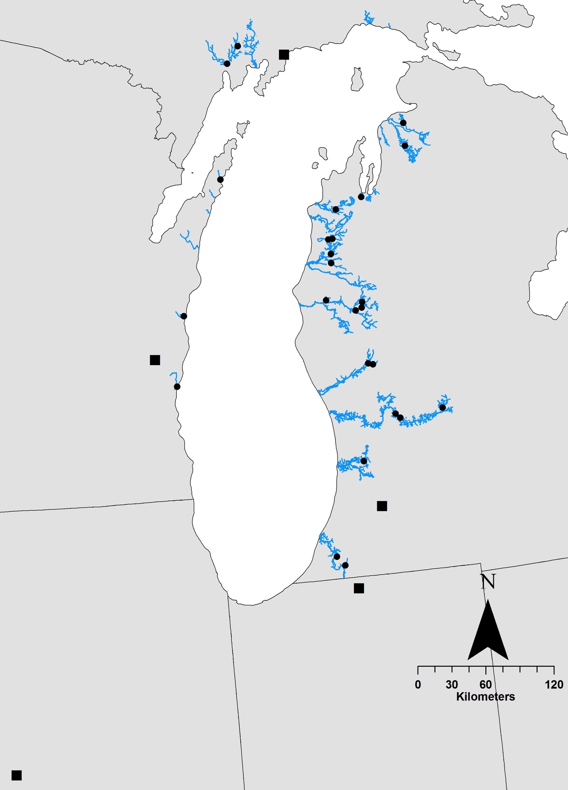
Figure 2.1. Sampling locations included in this study. Black dots correspond to stream sites and black squares correspond to hatcheries. Site abbreviations correspond to those listed in Tables 1 and 2.
HAYM
TSFH
DAYS
HIBB
FSHR
KMFH
SAUK
ILFH
HRTN
JRDN
KIDS
PLTE
LBER
LEMN
BEAR
PINE
WELD
SNBN
MBPM
LSPM
BGLW
MSST
EGPT
HNEY
PRRE
SLVR
WLFH
TWND
UNNM
BSFH

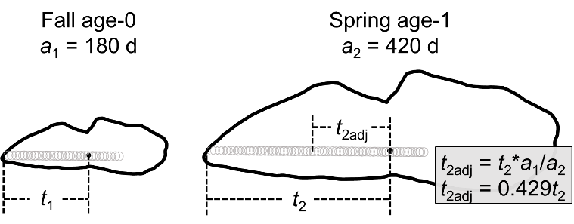

Figure 2.2. Graphical depiction of how transects and associated otolith chemistry data were truncated relative to the youngest fish used to develop each model. In this example, age-0 data included extend from the core to the otolith edge, and age-1 data extend from the core for a distance of 0.429t₂ (corresponding to t₁ and t_{2adj}, respectively).

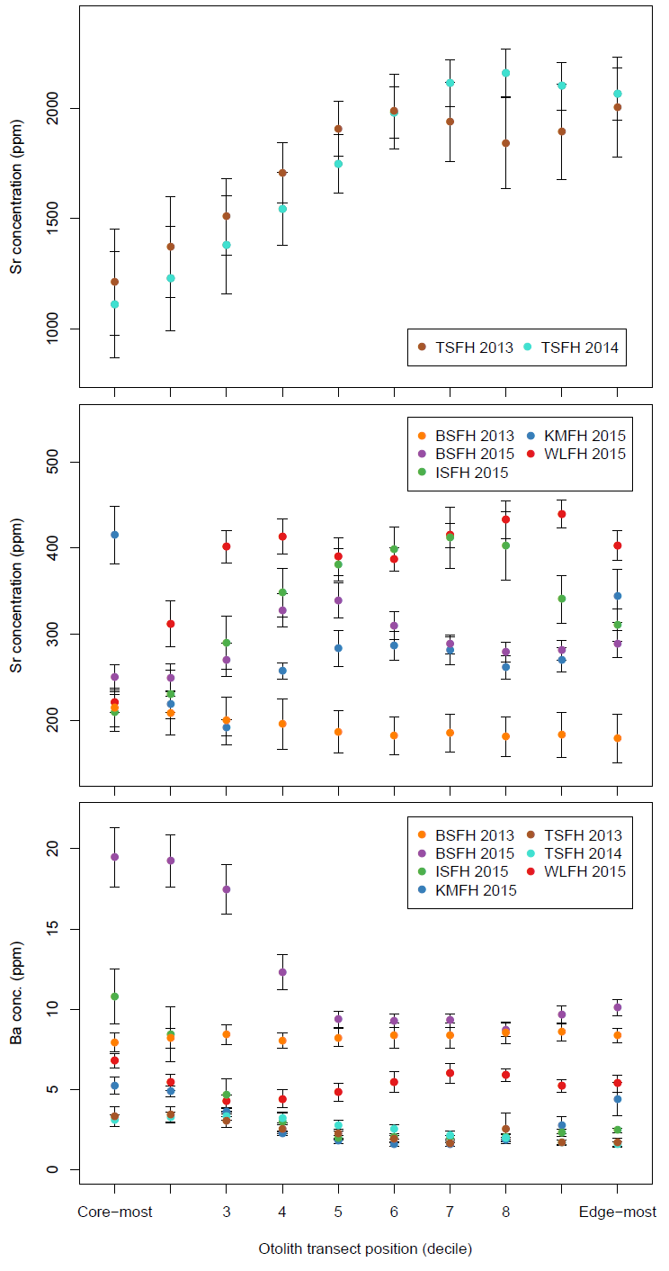

Figure 2.3. Elemental concentrations of the hatchery-origin juvenile steelhead described in Table 2.1. Points represent the transect decile mean concentrations among all the fish from a particular year class and hatchery. Error bars represent one standard error.

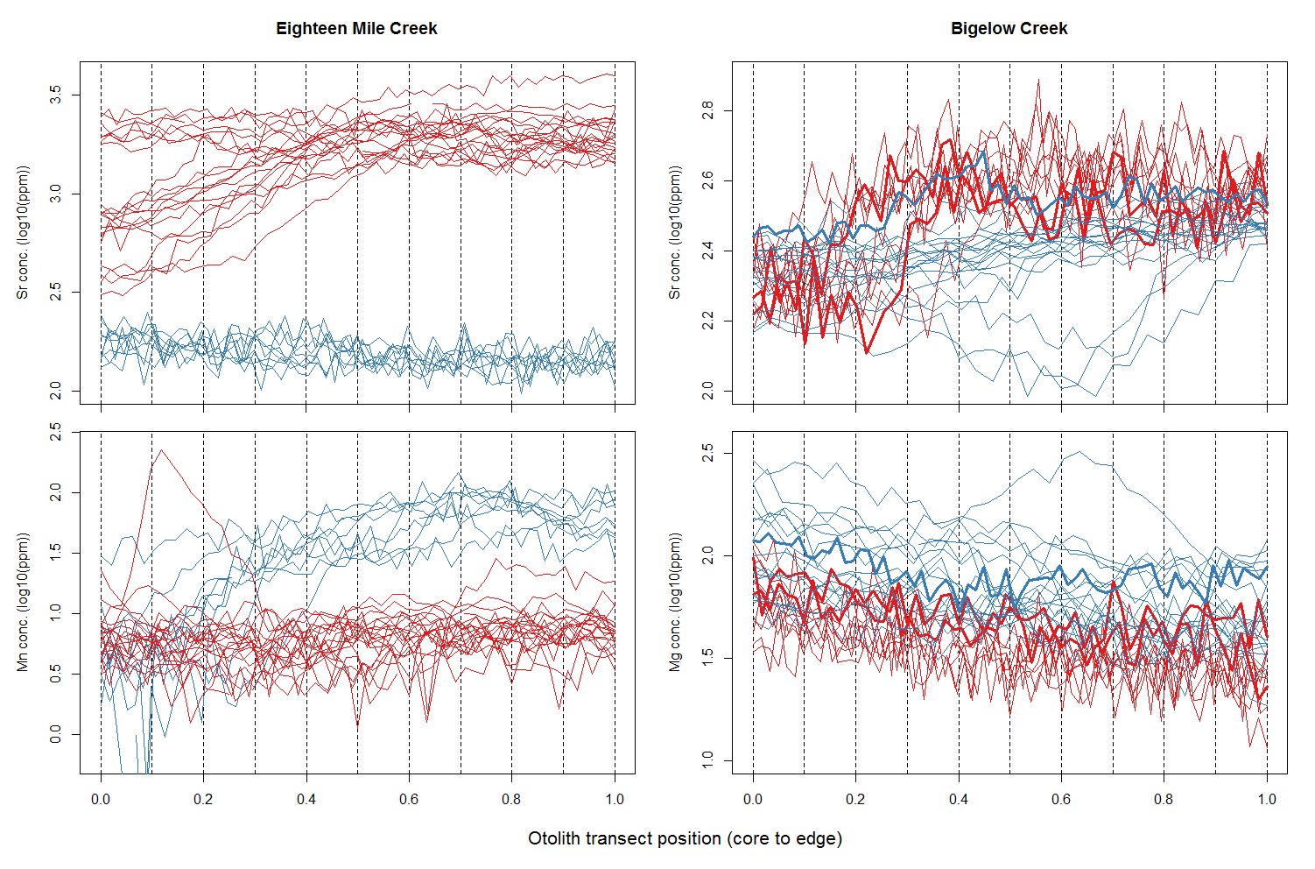

Figure 2.4. Raw elemental data of the known-origin wild (blue) and hatchery-origin (red) juvenile steelhead used to develop the site-specific classification models for Eighteen Mile (left) and Bigelow (right) creeks, the site-specific models that performed the best and poorest, respectively. Elements plotted are those that were most discriminatory for each respective site. Bold lines in the Bigelow Creek plots represent the fish that misclassified.

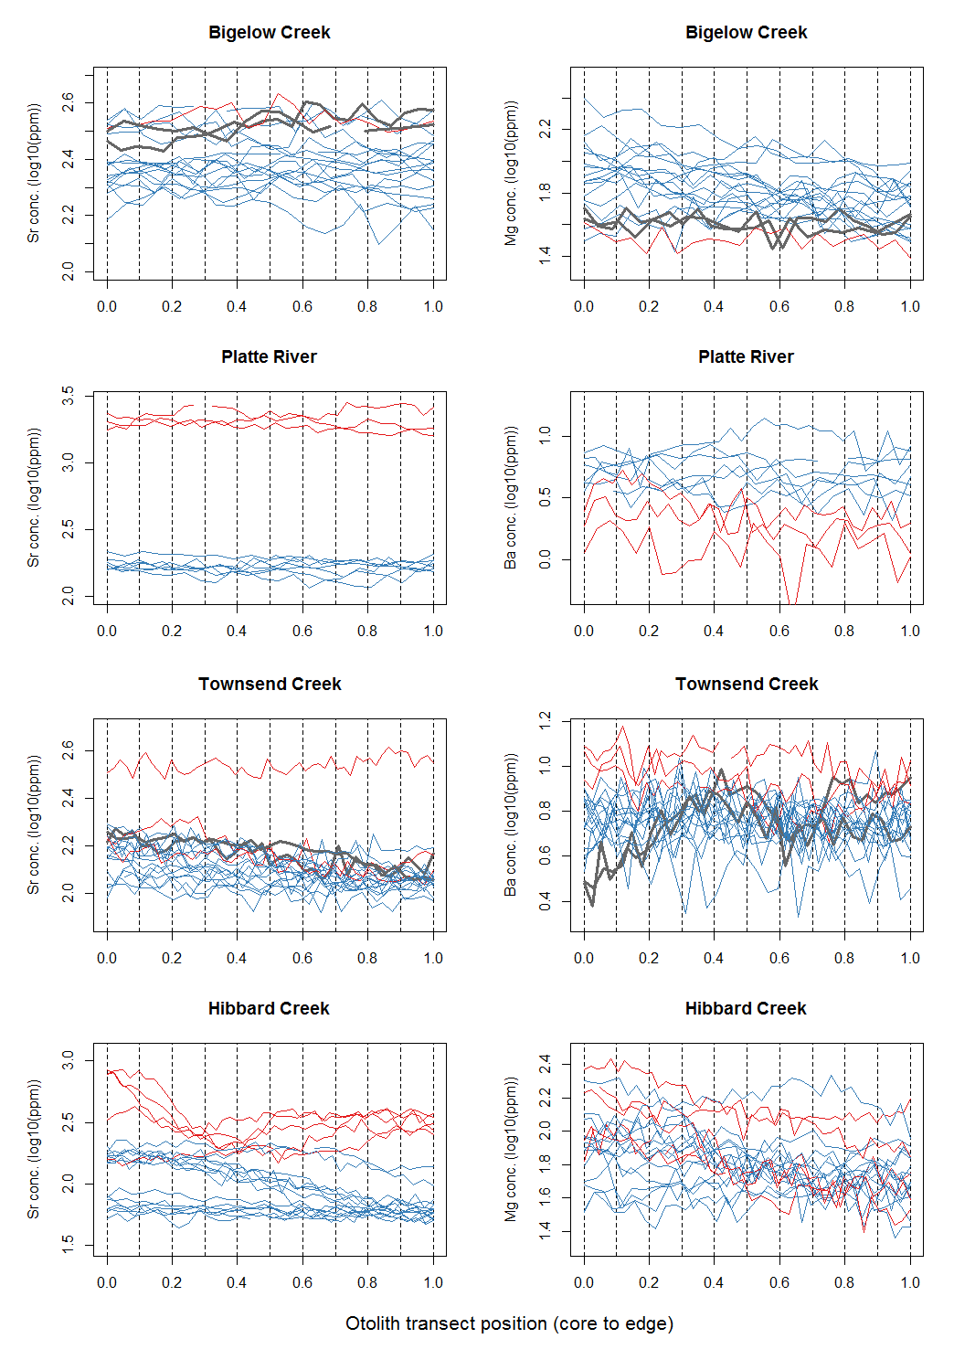

Figure 2.5. Raw elemental data of unknown-origin, age-1 juvenile steelhead (Table 1). Colors correspond to model-predicted origin assignments (red = hatchery origin, blue = wild origin; see Table 6). Each site displayed had juvenile steelhead that assigned to a different hatchery. Elements plotted are those that were most discriminatory for each respective site. Bold lines in the plots of Bigelow and Townsend creeks represent fish whose natal origin could not be determined.

SECTION 3: CLASSIFICATION OF LAKE MICHIGAN STEELHEAD ORIGIN AT DIFFERENT SPATIAL RESOLUTION

Introduction
Otoliths incorporate trace elements into their crystalline matrix at concentrations proportional to their abundance in the aquatic environment (Secor 1992, Thresher 1999, Campana and Thorrold 2001). We hypothesize that the chemical composition of otoliths near the core (i.e., the region created during early life stages) is unique to the location from which fish originated. This hypothesis is based on the following lines of evidence. 1) Water chemistry data from the US Geological Survey (USGS) National Stream Water-Quality Monitoring Network (Alexander et al. 1996) indicates that tributaries around Lake Michigan have distinct chemical signatures. Given that water chemistry strongly dictates otolith chemistry (Campana 1999), these results support the potential for tributary-specific signatures on the otolith. 2) Preliminary research indicates that natal origin of naturally-produced steelhead could be discriminated among three Lake Michigan tributaries (Black, Manistee, and St. Joseph’s; mean accuracy, 76.7%) and among sub-tributaries within the Manistee watershed (mean accuracy, 92.3%) using otolith chemistry (E. Rutherford, unpublished data). This research integrated the chemistry of the entire otolith, rather than using temporal patterns across transects of the otolith, the latter potentially providing even greater discriminatory power (see next point). 3) Finally, juvenile steelhead reside in their natal tributaries for a relatively long period (1-3 years; Stauffer 1972), allowing for a temporal component to the chemical signature. For example, seasonal changes in water chemistry unique to a given tributary may be reflected in the otolith chemistry. Although this temporal signature has not been used for naturally-produced steelhead in the Great Lakes basin, Boehler et al. (2012) recently demonstrated its power in accurately classifying the natal origin of hatchery reared Lake Erie steelhead. Importantly, Boehler et al. would have been unable to classify natal origin, if they had used the average chemistry of the entire otolith.
Here, we describe a test of the ability to classify the natal origins of steelhead at different spatial scales, ranging in resolution from individual streams to broader geographic and geological regions.

Methods
Collection, processing, and analysis of samples followed methodology described in Section 1. Importantly, we focused this analysis on naturally produced YOY fish (see Section 5 for YOY-YAO comparison) at collected in 2014 and 2015 from sites reported in Figure 1.1.
We evaluated classification accuracy at five different spatial resolutions. The first spatial classification scale provides the finest level of spatial resolution and is thus termed “fine” scale. This classifies fish back to an individual stream (Figure 1.1). Regions (Figure 3.1) were assigned based on spatial proximity and geology (Figure 3.2). Region 1 represents the finest regional classification scale with regions 2-4 progressively becoming coarser in nature (Figure 3.1).

Results

Elemental concentrations by site
Strontium concentrations varied between sites in both 2014 and 2015 (Figure 3.3). The highest naturally occurring values occurred in the Manistee and Little Manistee River watersheds (2014: LMAN 315.507 ± 70.539 ppm, TWIN 490.388 ± 40.729 ppm; 2015: LMAN 347.122 ± 48.974 ppm, LEMN 299.617 ± 76.062 ppm, TWIN 430.738 ± 86.579 ppm) and mainland Wisconsin (2014: 400.224 ± 38.455 ppm; 2015: SAUK 476.355 ± 60.908 ppm, FSHR 371.807 ± 35.047 ppm). Medusa Creek has the highest mean level of Sr (1,322.33 ± 122.466 ppm) among all sites in 2014, no YOY fish were collected from this site in 2015 but similar concentrations would be expected. Hibbards Creek had the lowest mean Sr concentrations in 2014 and 2015, 76.703 ± 35.508 ppm and 81.929 ± 30.786 ppm, respectively (Figure 3.3).
Barium concentrations varied between sites while mean concentrations were relatively low overall with a mean concentration for all sites of 5.937 ± 1.498 ppm in 2014 and 6.270 ± 1.535 ppm in 2015 (Figure 3.4). Concentrations of both Mg and Mn varied between sites in both years, though not to the extent of Sr and Ba (Figures 3.5, 3.6). Mean Cu concentrations were relatively low overall for both years with the exceptions of BGLW (8.967 ± 4.979 ppm) and WOOD (8.248 ± 2.747 ppm) in 2014 and BLCK (11.311 ± 6.647 ppm) and SAUK (11.473 ± 5.259 ppm) in 2015. Conversely, Cu concentrations were 4.333 ± 1.048 ppm for BLCK and 2.719 ± 1.318 ppm for SAUK in 2014 while in 2015, Cu concentrations were 1.379 ± 0.963 ppm for BGLW and 3.205 ± 1.997 ppm for WOOD. The mean concentrations of Zn across all sites were 112.797 ± 8.311 ppm in 2014 and 102.269 ± 9.976 ppm in 2015. Lead (Pb) concentrations were low for both years with mean concentrations across all sites of 0.772 ± 2.208 ppm in 2014 and 0.171 ± 0.329 ppm in 2015.

Spatial Analysis
When classifying fish to individual streams (i.e., fine resolution), mean classification accuracies were 86% for 2014 YOY (n = 179 fish, 18 classification groups), 75% for 2015 YOY (n = 325 fish, 32 classification groups), and 79% combined years (n = 514 fish, 34 classification groups) (Table 3.1). Six streams had 100% classification accuracy in the 2014 YOY model: SAUK, HIBB, BLCK, MDSA, KIDS, and SLVR (Table 3.2). Five streams had 100% classification accuracy in the 2015 YOY model: HIBB, WOOD, DAYS, HRTN, and MSST (Table 3.3). Nine streams had 100% classification accuracy in the combined years model: SAUK, HIBB, DAYS, BLCK, HRTN, KIDS, MDSA, MSST, and TWND (Table 3.4).
When classifying fish using the finest regional resolution (R1), mean classification accuracies were 88% for 2014 YOY (n = 13 classification groups), 89% for 2015 YOY (n = 13 classification groups), and 89% combined years (n = 14 classification groups) (Table 3.1). Five classification groups had 100% accuracy in the 2014 model: WIM, EUP, MDS, TVC, and KZO. Four with 100% classification accuracy in the 2015 model: WIM, WID, WUP, and NMI; and three in the combined years model: WIM, WUP, and MDS.
When using the moderate regional resolution (R2) model for classifying fish, mean classification accuracies were 89% for 2014 YOY (n = 9 classification groups), 89% for 2015 YOY (n = 9 classification groups), and 91% combined years (n = 10 classification groups) (Table 3.1). Three classification groups had 100% accuracy in the 2014 model: WIM, MDS, and KZO; four in the 2015 model: WIM, WID, WUP, and NMI; and three in the combined years model: WIM, WUP, and MDS.
When using the moderate/coarse regional resolution (R3) model for classifying fish, mean classification accuracies were 92% for 2014 YOY (n = 7 classification groups), 92% for 2015 YOY (n = 6 classification groups), and 93% combined years (n = 7 classification groups) (Table 3.1). Two classification groups had 100% accuracy in the 2014 model: UPP and MDS; one in the 2015 model: WIS; and one in the combined years model: MDS. Many other classification groups in each model had accuracies in the 90 percentile range.
When using the coarse regional resolution (R4) model for classifying fish, mean classification accuracies were 91% for 2014 YOY (n = 6 classification groups), 92% for 2015 YOY (n = 5 classification groups), and 92% combined years (n = 6 classification groups) (Table 3.1). One classification groups had 100% accuracy in the 2014 model: MDS; two in the 2015 model: WIS and NMI; and one in the combined years model: MDS. Many other classification groups in each model had accuracies in the 90 percentile range.
Generally, classification accuracy increased as the number of classification groups decreased (Figure 3.7). Models using five classification groups had a mean classification accuracy of 93.5%, those with ten decreased to 90% accuracy, and the model with 34 classification groups had a mean accuracy of 79%.

Variables of Importance
Of the seven elements included in our analysis, strontium was found to be the predictor variable of most importance for both years, based on mean decrease gini values (Figures 3.8 and 3.9). For the 2014 YOY analysis, the predictor variables of importance ranked by the average mean decrease gini values ± standard error (average of the ten values for each section of the ablation transect) were Sr (6.227 ± 0.591), Mg (2.752 ± 0.412), Ba (2.327 ± 0.128), Mn (1.883 ± 0.339), Pb (1.692 ± 0.420), Cu (1.053 ± 0.101), Zn (0.866 ± 0.160). When considering the 12 most important predictor variables, Sr constituted 10 of the 12 (Figure 3.8). For the 2015 YOY analysis, the predictor variables of importance ranked by the average mean decrease gini values ± standard error (average of the ten values for each section of the ablation transect) were Sr (8.995 ± 0.981), Mn (5.714 ± 0.901), Ba (4.466 ± 0.370), Mg (4.101 ± 0.830), Pb (2.896 ± 0.207), Cu (2.659 ± 0.045), Zn (2.550 ± 0.486). When considering the 12 most important predictor variables in the 2015 model, Sr constituted 7 of the 12 (Figure 3.8). Across both years Sr, Mg, Ba and Mn were the four most important predictor variables.

Table 3.1. Classification accuracies for spatial resolution analysis across the five spatial scales.

 | Fine | Region 1 | Region 2 | Region 3 | Region 4
2014 YOY | 86% | 88% | 89% | 92% | 91%
2015 YOY | 75% | 89% | 89% | 92% | 92%
Combined Years | 79% | 89% | 91% | 93% | 92%

Table 3.2. Classifications based on random forest model for 2014 YOY fish. Sites (classification groups) are ordered based on geographic location starting with mainland Wisconsin, then through the Door Peninsula, across Michigan’s Upper Peninsula from west to east, then down through the Lower Peninsula, ending with southern Lower Peninsula sites. The gray shaded squares are representative of the number of correctly classified fish based on otolith chemistry. The far left column represents the classification group the fish was originally from. The top row represents the location to which the fish classified based upon the random forest model. CA (classification accuracy) represents percentage of fish classifying correctly to each site.

 | SAUK | HIBB | WOOD | BLCK | ANTM | MDSA | KIDS | BEAR | PINE | LMAN | TWIN | LSPM | MBPM | WELD | BGLW | PRRE | SLVR | TWND | CA (%)
SAUK | 10 | 0 | 0 | 0 | 0 | 0 | 0 | 0 | 0 | 0 | 0 | 0 | 0 | 0 | 0 | 0 | 0 | 0 | 100
HIBB | 0 | 9 | 0 | 0 | 0 | 0 | 0 | 0 | 0 | 0 | 0 | 0 | 0 | 0 | 0 | 0 | 0 | 0 | 100
WOOD | 0 | 0 | 7 | 0 | 0 | 0 | 0 | 0 | 0 | 0 | 0 | 0 | 0 | 0 | 1 | 0 | 0 | 2 | 70
BLCK | 0 | 0 | 0 | 10 | 0 | 0 | 0 | 0 | 0 | 0 | 0 | 0 | 0 | 0 | 0 | 0 | 0 | 0 | 100
ANTM | 0 | 1 | 0 | 0 | 8 | 1 | 0 | 0 | 0 | 0 | 0 | 0 | 0 | 0 | 0 | 0 | 0 | 0 | 80
MDSA | 0 | 0 | 0 | 0 | 0 | 10 | 0 | 0 | 0 | 0 | 0 | 0 | 0 | 0 | 0 | 0 | 0 | 0 | 100
KIDS | 0 | 0 | 0 | 0 | 0 | 0 | 11 | 0 | 0 | 0 | 0 | 0 | 0 | 0 | 0 | 0 | 0 | 0 | 100
BEAR | 0 | 0 | 0 | 0 | 0 | 0 | 0 | 9 | 0 | 0 | 0 | 0 | 0 | 0 | 0 | 0 | 1 | 0 | 90
PINE | 0 | 0 | 0 | 0 | 0 | 0 | 0 | 0 | 8 | 0 | 0 | 0 | 1 | 3 | 0 | 0 | 0 | 0 | 67
LMAN | 1 | 0 | 0 | 0 | 0 | 0 | 0 | 0 | 0 | 9 | 0 | 0 | 0 | 0 | 0 | 0 | 0 | 0 | 90
TWIN | 0 | 0 | 0 | 0 | 1 | 0 | 0 | 0 | 0 | 1 | 9 | 0 | 0 | 0 | 0 | 0 | 0 | 0 | 82
LSPM | 0 | 0 | 0 | 0 | 0 | 0 | 0 | 1 | 0 | 0 | 0 | 9 | 0 | 0 | 0 | 0 | 0 | 0 | 90
MBPM | 0 | 0 | 0 | 0 | 0 | 0 | 0 | 0 | 2 | 0 | 0 | 0 | 7 | 0 | 0 | 1 | 0 | 0 | 70
WELD | 0 | 0 | 0 | 0 | 0 | 0 | 0 | 0 | 3 | 0 | 0 | 0 | 0 | 6 | 0 | 0 | 0 | 0 | 67
BGLW | 1 | 0 | 0 | 0 | 0 | 0 | 0 | 1 | 0 | 1 | 0 | 0 | 0 | 0 | 6 | 0 | 0 | 0 | 67
PRRE | 0 | 0 | 0 | 0 | 0 | 0 | 0 | 0 | 0 | 0 | 0 | 0 | 1 | 0 | 0 | 6 | 0 | 0 | 86
SLVR | 0 | 0 | 0 | 0 | 0 | 0 | 0 | 0 | 0 | 0 | 0 | 0 | 0 | 0 | 0 | 0 | 11 | 0 | 100
TWND | 0 | 0 | 1 | 0 | 0 | 0 | 0 | 0 | 0 | 0 | 0 | 0 | 0 | 0 | 0 | 0 | 0 | 9 | 90

Table 3.3. Classifications based on random forest model for 2015 YOY fish. The gray shaded squares are representative of the number of correctly classified fish based on otolith chemistry. The far left column represents the classification group the fish was originally from. The top row represents the location to which the fish classified based upon the random forest model. CA (classification accuracy) represents percentage of fish classifying correctly to each site.
 | FSHR | SAUK | HIBB | WOOD | 18MI | DAYS | HAYM | BLCK | CUTR | HRTN | ACME | KIDS | LBET | BEAR | LBER | LEMN | PINE | COOL | LMAN | TWIN | LSPM | MBPM | SNBN | WELD | BGLW | MSST | EGPT | HNEY | PRRE | SLVR | TWND | UNNM | CA (%)
FSHR | 9 | 1 | 0 | 0 | 0 | 0 | 0 | 0 | 0 | 0 | 0 | 0 | 0 | 0 | 0 | 0 | 0 | 0 | 0 | 0 | 0 | 0 | 0 | 0 | 0 | 0 | 0 | 0 | 0 | 0 | 0 | 0 | 90
SAUK | 1 | 9 | 0 | 0 | 0 | 0 | 0 | 0 | 0 | 0 | 0 | 0 | 0 | 0 | 0 | 0 | 0 | 0 | 0 | 0 | 0 | 0 | 0 | 0 | 0 | 0 | 0 | 0 | 0 | 0 | 0 | 0 | 90
HIBB | 0 | 0 | 10 | 0 | 0 | 0 | 0 | 0 | 0 | 0 | 0 | 0 | 0 | 0 | 0 | 0 | 0 | 0 | 0 | 0 | 0 | 0 | 0 | 0 | 0 | 0 | 0 | 0 | 0 | 0 | 0 | 0 | 100
WOOD | 0 | 0 | 0 | 10 | 0 | 0 | 0 | 0 | 0 | 0 | 0 | 0 | 0 | 0 | 0 | 0 | 0 | 0 | 0 | 0 | 0 | 0 | 0 | 0 | 0 | 0 | 0 | 0 | 0 | 0 | 0 | 0 | 100
18MI | 0 | 0 | 0 | 0 | 5 | 1 | 3 | 0 | 0 | 0 | 0 | 0 | 0 | 0 | 0 | 0 | 0 | 0 | 0 | 0 | 0 | 0 | 0 | 0 | 0 | 0 | 0 | 0 | 0 | 0 | 0 | 0 | 56
DAYS | 0 | 0 | 0 | 0 | 0 | 10 | 0 | 0 | 0 | 0 | 0 | 0 | 0 | 0 | 0 | 0 | 0 | 0 | 0 | 0 | 0 | 0 | 0 | 0 | 0 | 0 | 0 | 0 | 0 | 0 | 0 | 0 | 100
HAYM | 0 | 0 | 0 | 0 | 2 | 0 | 8 | 0 | 0 | 0 | 0 | 0 | 0 | 0 | 0 | 0 | 0 | 0 | 0 | 0 | 0 | 0 | 0 | 0 | 0 | 0 | 0 | 0 | 0 | 0 | 0 | 0 | 80
BLCK | 0 | 0 | 0 | 0 | 0 | 0 | 0 | 9 | 0 | 0 | 0 | 1 | 0 | 0 | 0 | 0 | 0 | 0 | 0 | 0 | 0 | 0 | 0 | 0 | 0 | 0 | 0 | 0 | 0 | 0 | 0 | 0 | 90
CUTR | 0 | 0 | 0 | 0 | 0 | 0 | 0 | 2 | 8 | 0 | 0 | 0 | 0 | 0 | 0 | 0 | 0 | 0 | 0 | 0 | 0 | 0 | 0 | 0 | 0 | 0 | 0 | 0 | 0 | 0 | 0 | 0 | 80
HRTN | 0 | 0 | 0 | 0 | 0 | 0 | 0 | 0 | 0 | 10 | 0 | 0 | 0 | 0 | 0 | 0 | 0 | 0 | 0 | 0 | 0 | 0 | 0 | 0 | 0 | 0 | 0 | 0 | 0 | 0 | 0 | 0 | 100
ACME | 0 | 0 | 0 | 0 | 0 | 0 | 0 | 0 | 1 | 0 | 8 | 1 | 0 | 0 | 0 | 0 | 0 | 0 | 0 | 0 | 0 | 0 | 0 | 0 | 0 | 0 | 0 | 0 | 0 | 0 | 0 | 0 | 80
KIDS | 0 | 0 | 0 | 0 | 0 | 0 | 0 | 0 | 0 | 0 | 0 | 10 | 0 | 0 | 0 | 0 | 0 | 0 | 0 | 0 | 0 | 0 | 0 | 0 | 0 | 0 | 0 | 0 | 0 | 0 | 0 | 0 | 0
LBET | 0 | 0 | 0 | 0 | 0 | 0 | 0 | 0 | 0 | 0 | 0 | 0 | 7 | 0 | 0 | 0 | 2 | 0 | 0 | 0 | 0 | 0 | 0 | 0 | 0 | 0 | 0 | 1 | 0 | 0 | 0 | 0 | 70
BEAR | 0 | 0 | 0 | 0 | 0 | 0 | 0 | 0 | 0 | 0 | 0 | 0 | 0 | 6 | 0 | 0 | 0 | 0 | 0 | 0 | 0 | 1 | 0 | 1 | 0 | 0 | 1 | 0 | 1 | 0 | 0 | 0 | 60
LBER | 0 | 0 | 0 | 0 | 0 | 0 | 0 | 0 | 0 | 0 | 0 | 0 | 2 | 0 | 5 | 0 | 0 | 0 | 0 | 0 | 0 | 1 | 0 | 0 | 0 | 0 | 0 | 1 | 1 | 0 | 0 | 0 | 50
LEMN | 0 | 1 | 0 | 0 | 0 | 0 | 0 | 0 | 0 | 0 | 0 | 0 | 0 | 0 | 0 | 7 | 0 | 0 | 0 | 0 | 0 | 0 | 0 | 0 | 1 | 0 | 0 | 0 | 1 | 0 | 0 | 0 | 70
PINE | 0 | 0 | 0 | 0 | 0 | 0 | 0 | 0 | 0 | 0 | 0 | 0 | 1 | 0 | 0 | 0 | 8 | 0 | 0 | 0 | 0 | 0 | 0 | 1 | 0 | 0 | 0 | 0 | 0 | 0 | 0 | 0 | 80
COOL | 0 | 0 | 0 | 0 | 0 | 0 | 0 | 0 | 0 | 0 | 0 | 0 | 0 | 1 | 0 | 0 | 1 | 4 | 2 | 0 | 0 | 0 | 0 | 0 | 1 | 0 | 0 | 0 | 1 | 0 | 0 | 0 | 40
LMAN | 0 | 0 | 0 | 0 | 0 | 0 | 0 | 0 | 0 | 0 | 0 | 0 | 0 | 0 | 0 | 0 | 0 | 0 | 7 | 1 | 0 | 0 | 0 | 0 | 2 | 0 | 0 | 0 | 0 | 0 | 0 | 0 | 70
TWIN | 0 | 0 | 0 | 0 | 0 | 0 | 0 | 0 | 0 | 0 | 0 | 0 | 0 | 0 | 0 | 0 | 0 | 0 | 1 | 9 | 0 | 0 | 0 | 0 | 0 | 0 | 0 | 0 | 0 | 0 | 0 | 0 | 90
LSPM | 0 | 0 | 0 | 0 | 0 | 0 | 0 | 0 | 0 | 0 | 0 | 0 | 0 | 0 | 0 | 0 | 0 | 0 | 0 | 0 | 6 | 0 | 0 | 0 | 0 | 0 | 2 | 1 | 0 | 1 | 0 | 0 | 60
MBPM | 0 | 0 | 0 | 0 | 0 | 0 | 0 | 0 | 0 | 0 | 0 | 0 | 0 | 0 | 1 | 0 | 0 | 0 | 0 | 0 | 0 | 7 | 1 | 0 | 0 | 0 | 0 | 0 | 1 | 0 | 0 | 0 | 70
SNBN | 0 | 0 | 0 | 0 | 0 | 0 | 0 | 0 | 0 | 0 | 0 | 0 | 0 | 0 | 0 | 0 | 0 | 0 | 0 | 0 | 0 | 4 | 2 | 0 | 0 | 0 | 0 | 1 | 2 | 0 | 0 | 1 | 20
WELD | 0 | 0 | 0 | 0 | 0 | 0 | 0 | 0 | 0 | 0 | 0 | 0 | 2 | 1 | 1 | 0 | 1 | 0 | 0 | 0 | 2 | 0 | 0 | 2 | 1 | 0 | 0 | 0 | 0 | 0 | 0 | 0 | 20
BGLW | 0 | 0 | 0 | 0 | 0 | 0 | 0 | 0 | 0 | 0 | 0 | 0 | 0 | 0 | 0 | 0 | 0 | 0 | 1 | 0 | 0 | 0 | 0 | 0 | 9 | 0 | 0 | 0 | 0 | 0 | 0 | 0 | 90
MSST | 0 | 0 | 0 | 0 | 0 | 0 | 0 | 0 | 0 | 0 | 0 | 0 | 0 | 0 | 0 | 0 | 0 | 0 | 0 | 0 | 0 | 0 | 0 | 0 | 0 | 10 | 0 | 0 | 0 | 0 | 0 | 0 | 100
EGPT | 0 | 0 | 0 | 0 | 0 | 0 | 0 | 0 | 0 | 0 | 0 | 0 | 0 | 0 | 0 | 0 | 0 | 0 | 0 | 0 | 1 | 1 | 0 | 0 | 0 | 0 | 9 | 0 | 1 | 1 | 0 | 0 | 69
HNEY | 0 | 0 | 0 | 0 | 0 | 0 | 0 | 0 | 0 | 0 | 0 | 0 | 2 | 0 | 0 | 0 | 1 | 0 | 0 | 0 | 0 | 0 | 0 | 1 | 1 | 0 | 0 | 5 | 0 | 0 | 0 | 0 | 50
PRRE | 0 | 0 | 0 | 0 | 0 | 0 | 0 | 0 | 0 | 0 | 0 | 0 | 0 | 0 | 0 | 0 | 0 | 0 | 0 | 0 | 0 | 0 | 1 | 0 | 0 | 1 | 0 | 0 | 11 | 0 | 0 | 0 | 85
SLVR | 0 | 0 | 0 | 0 | 0 | 0 | 0 | 0 | 0 | 0 | 0 | 0 | 1 | 0 | 0 | 0 | 0 | 0 | 0 | 0 | 0 | 0 | 0 | 0 | 0 | 0 | 0 | 0 | 0 | 9 | 0 | 0 | 90
TWND | 0 | 0 | 0 | 1 | 0 | 0 | 0 | 0 | 0 | 0 | 0 | 0 | 0 | 0 | 0 | 0 | 0 | 0 | 0 | 0 | 0 | 0 | 0 | 0 | 0 | 0 | 0 | 0 | 1 | 0 | 8 | 0 | 80
UNNM | 0 | 0 | 0 | 0 | 0 | 0 | 0 | 0 | 0 | 0 | 0 | 0 | 0 | 0 | 0 | 0 | 0 | 0 | 0 | 0 | 0 | 0 | 0 | 0 | 0 | 0 | 0 | 0 | 0 | 0 | 3 | 7 | 70

Table 3.4. Classifications based on RF model for combined years. Gray shaded squares represent the number correctly classified fish. Far left column represents the original classification group of the fish. Top row represents the location to which the fish classified based upon RF model. CA % represents percentage of fish classifying correctly to each site.
 | FSHR | SAUK | HIBB | WOOD | DAYS | 18MI | HAYM | BLCK | CUTR | ANTM | HRTN | ACME | KIDS | MDSA | LBET | BEAR | LBER | LEMN | PINE | COOL | LMAN | TWIN | LSPM | MBPM | SNBN | WELD | BGLW | MSST | EGPT | HNEY | PRRE | SLVR | TWND | UNNM | CA (%)
FSHR | 8 | 2 | 0 | 0 | 0 | 0 | 0 | 0 | 0 | 0 | 0 | 0 | 0 | 0 | 0 | 0 | 0 | 0 | 0 | 0 | 0 | 0 | 0 | 0 | 0 | 0 | 0 | 0 | 0 | 0 | 0 | 0 | 0 | 0 | 80
SAUK | 0 | 20 | 0 | 0 | 0 | 0 | 0 | 0 | 0 | 0 | 0 | 0 | 0 | 0 | 0 | 0 | 0 | 0 | 0 | 0 | 0 | 0 | 0 | 0 | 0 | 0 | 0 | 0 | 0 | 0 | 0 | 0 | 0 | 0 | 100
HIBB | 0 | 0 | 19 | 0 | 0 | 0 | 0 | 0 | 0 | 0 | 0 | 0 | 0 | 0 | 0 | 0 | 0 | 0 | 0 | 0 | 0 | 0 | 0 | 0 | 0 | 0 | 0 | 0 | 0 | 0 | 0 | 0 | 0 | 0 | 100
WOOD | 0 | 0 | 0 | 17 | 0 | 0 | 0 | 0 | 0 | 0 | 0 | 0 | 0 | 0 | 0 | 0 | 0 | 0 | 0 | 0 | 0 | 0 | 0 | 0 | 0 | 0 | 1 | 0 | 0 | 0 | 0 | 0 | 2 | 0 | 85
DAYS | 0 | 0 | 0 | 0 | 10 | 0 | 0 | 0 | 0 | 0 | 0 | 0 | 0 | 0 | 0 | 0 | 0 | 0 | 0 | 0 | 0 | 0 | 0 | 0 | 0 | 0 | 0 | 0 | 0 | 0 | 0 | 0 | 0 | 0 | 100
18MI | 0 | 0 | 0 | 0 | 1 | 6 | 2 | 0 | 0 | 0 | 0 | 0 | 0 | 0 | 0 | 0 | 0 | 0 | 0 | 0 | 0 | 0 | 0 | 0 | 0 | 0 | 0 | 0 | 0 | 0 | 0 | 0 | 0 | 0 | 67
HAYM | 0 | 0 | 0 | 0 | 0 | 2 | 8 | 0 | 0 | 0 | 0 | 0 | 0 | 0 | 0 | 0 | 0 | 0 | 0 | 0 | 0 | 0 | 0 | 0 | 0 | 0 | 0 | 0 | 0 | 0 | 0 | 0 | 0 | 0 | 80
BLCK | 0 | 0 | 0 | 0 | 0 | 0 | 0 | 20 | 0 | 0 | 0 | 0 | 0 | 0 | 0 | 0 | 0 | 0 | 0 | 0 | 0 | 0 | 0 | 0 | 0 | 0 | 0 | 0 | 0 | 0 | 0 | 0 | 0 | 0 | 100
CUTR | 0 | 0 | 0 | 0 | 0 | 0 | 0 | 4 | 5 | 0 | 0 | 0 | 1 | 0 | 0 | 0 | 0 | 0 | 0 | 0 | 0 | 0 | 0 | 0 | 0 | 0 | 0 | 0 | 0 | 0 | 0 | 0 | 0 | 0 | 50
ANTM | 0 | 0 | 1 | 1 | 0 | 0 | 0 | 0 | 0 | 4 | 1 | 2 | 0 | 1 | 0 | 0 | 0 | 0 | 0 | 0 | 0 | 0 | 0 | 0 | 0 | 0 | 0 | 0 | 0 | 0 | 0 | 0 | 0 | 0 | 40
HRTN | 0 | 0 | 0 | 0 | 0 | 0 | 0 | 0 | 0 | 0 | 10 | 0 | 0 | 0 | 0 | 0 | 0 | 0 | 0 | 0 | 0 | 0 | 0 | 0 | 0 | 0 | 0 | 0 | 0 | 0 | 0 | 0 | 0 | 0 | 100
ACME | 0 | 0 | 0 | 0 | 0 | 0 | 0 | 0 | 0 | 1 | 0 | 8 | 1 | 0 | 0 | 0 | 0 | 0 | 0 | 0 | 0 | 0 | 0 | 0 | 0 | 0 | 0 | 0 | 0 | 0 | 0 | 0 | 0 | 0 | 80
KIDS | 0 | 0 | 0 | 0 | 0 | 0 | 0 | 0 | 0 | 0 | 0 | 0 | 31 | 0 | 0 | 0 | 0 | 0 | 0 | 0 | 0 | 0 | 0 | 0 | 0 | 0 | 0 | 0 | 0 | 0 | 0 | 0 | 0 | 0 | 100
MDSA | 0 | 0 | 0 | 0 | 0 | 0 | 0 | 0 | 0 | 0 | 0 | 0 | 0 | 10 | 0 | 0 | 0 | 0 | 0 | 0 | 0 | 0 | 0 | 0 | 0 | 0 | 0 | 0 | 0 | 0 | 0 | 0 | 0 | 0 | 100
LBET | 0 | 0 | 0 | 0 | 0 | 0 | 0 | 0 | 0 | 0 | 0 | 0 | 0 | 0 | 6 | 0 | 0 | 0 | 2 | 0 | 0 | 0 | 0 | 1 | 0 | 0 | 0 | 0 | 0 | 1 | 0 | 0 | 0 | 0 | 60
BEAR | 0 | 0 | 0 | 0 | 0 | 0 | 0 | 0 | 0 | 0 | 0 | 0 | 0 | 0 | 0 | 13 | 0 | 0 | 0 | 0 | 0 | 0 | 1 | 0 | 0 | 1 | 0 | 0 | 0 | 0 | 4 | 1 | 0 | 0 | 65
LBER | 0 | 0 | 0 | 0 | 0 | 0 | 0 | 0 | 0 | 0 | 0 | 0 | 0 | 0 | 2 | 1 | 4 | 0 | 0 | 0 | 0 | 0 | 2 | 0 | 0 | 0 | 0 | 0 | 0 | 0 | 1 | 0 | 0 | 0 | 40
LEMN | 0 | 1 | 0 | 0 | 0 | 0 | 0 | 0 | 0 | 0 | 0 | 0 | 0 | 0 | 0 | 1 | 0 | 8 | 0 | 0 | 0 | 0 | 0 | 0 | 0 | 0 | 0 | 0 | 0 | 0 | 0 | 0 | 0 | 0 | 80
PINE | 0 | 0 | 0 | 0 | 0 | 0 | 0 | 0 | 0 | 0 | 0 | 0 | 0 | 0 | 0 | 0 | 0 | 0 | 17 | 0 | 0 | 0 | 1 | 0 | 0 | 4 | 0 | 0 | 0 | 0 | 0 | 0 | 0 | 0 | 77
COOL | 0 | 0 | 0 | 0 | 0 | 0 | 0 | 0 | 0 | 0 | 0 | 0 | 0 | 0 | 0 | 0 | 0 | 0 | 1 | 2 | 3 | 0 | 0 | 0 | 0 | 0 | 1 | 0 | 0 | 0 | 3 | 0 | 0 | 0 | 20
LMAN | 0 | 0 | 0 | 0 | 0 | 0 | 0 | 0 | 0 | 0 | 0 | 0 | 0 | 0 | 0 | 0 | 0 | 0 | 0 | 0 | 19 | 1 | 0 | 0 | 0 | 0 | 0 | 0 | 0 | 0 | 0 | 0 | 0 | 0 | 95
TWIN | 0 | 0 | 0 | 0 | 0 | 0 | 0 | 1 | 0 | 0 | 0 | 0 | 0 | 0 | 0 | 0 | 0 | 0 | 0 | 0 | 1 | 19 | 0 | 0 | 0 | 0 | 0 | 0 | 0 | 0 | 0 | 0 | 0 | 0 | 90
LSPM | 0 | 0 | 0 | 0 | 0 | 0 | 0 | 0 | 0 | 0 | 0 | 0 | 0 | 0 | 0 | 0 | 0 | 0 | 0 | 0 | 0 | 0 | 17 | 1 | 0 | 0 | 0 | 0 | 0 | 1 | 0 | 1 | 0 | 0 | 85
MBPM | 0 | 0 | 0 | 0 | 0 | 0 | 0 | 0 | 0 | 0 | 0 | 0 | 0 | 0 | 0 | 0 | 0 | 0 | 1 | 0 | 0 | 0 | 0 | 18 | 0 | 0 | 0 | 0 | 0 | 0 | 1 | 0 | 0 | 0 | 90
SNBN | 0 | 0 | 0 | 0 | 0 | 0 | 0 | 0 | 0 | 0 | 0 | 0 | 0 | 0 | 0 | 0 | 0 | 0 | 0 | 0 | 0 | 0 | 0 | 4 | 2 | 0 | 0 | 0 | 0 | 1 | 2 | 0 | 0 | 1 | 20
WELD | 0 | 0 | 0 | 0 | 0 | 0 | 0 | 0 | 0 | 0 | 0 | 0 | 0 | 0 | 0 | 1 | 0 | 0 | 7 | 0 | 0 | 0 | 2 | 0 | 0 | 8 | 1 | 0 | 0 | 0 | 0 | 0 | 0 | 0 | 42
BGLW | 0 | 1 | 0 | 0 | 0 | 0 | 0 | 0 | 0 | 0 | 0 | 0 | 0 | 0 | 0 | 1 | 0 | 0 | 0 | 0 | 1 | 0 | 0 | 0 | 0 | 0 | 16 | 0 | 0 | 0 | 0 | 0 | 0 | 0 | 84
MSST | 0 | 0 | 0 | 0 | 0 | 0 | 0 | 0 | 0 | 0 | 0 | 0 | 0 | 0 | 0 | 0 | 0 | 0 | 0 | 0 | 0 | 0 | 0 | 0 | 0 | 0 | 0 | 10 | 0 | 0 | 0 | 0 | 0 | 0 | 100
EGPT | 0 | 0 | 0 | 0 | 0 | 0 | 0 | 0 | 0 | 0 | 0 | 0 | 0 | 0 | 0 | 1 | 0 | 0 | 0 | 0 | 0 | 0 | 2 | 1 | 0 | 0 | 0 | 0 | 8 | 0 | 1 | 0 | 0 | 0 | 62
HNEY | 0 | 0 | 0 | 0 | 0 | 0 | 0 | 0 | 0 | 0 | 0 | 0 | 0 | 0 | 1 | 0 | 0 | 0 | 1 | 0 | 0 | 0 | 2 | 0 | 0 | 1 | 1 | 0 | 0 | 4 | 0 | 0 | 0 | 0 | 40
PRRE | 0 | 0 | 0 | 0 | 0 | 0 | 0 | 0 | 0 | 0 | 0 | 0 | 0 | 0 | 0 | 0 | 0 | 0 | 0 | 0 | 0 | 0 | 0 | 2 | 0 | 0 | 0 | 1 | 0 | 0 | 17 | 0 | 0 | 0 | 85
SLVR | 0 | 0 | 0 | 0 | 0 | 0 | 0 | 0 | 0 | 0 | 0 | 0 | 0 | 0 | 1 | 0 | 0 | 0 | 0 | 0 | 0 | 0 | 1 | 0 | 0 | 0 | 0 | 0 | 0 | 0 | 0 | 19 | 0 | 0 | 90
TWND | 0 | 0 | 0 | 0 | 0 | 0 | 0 | 0 | 0 | 0 | 0 | 0 | 0 | 0 | 0 | 0 | 0 | 0 | 0 | 0 | 0 | 0 | 0 | 0 | 0 | 0 | 0 | 0 | 0 | 0 | 0 | 0 | 20 | 0 | 100
UNNM | 0 | 0 | 0 | 1 | 0 | 0 | 0 | 0 | 0 | 0 | 0 | 0 | 0 | 0 | 0 | 0 | 0 | 0 | 0 | 0 | 0 | 0 | 0 | 0 | 0 | 0 | 0 | 0 | 0 | 0 | 0 | 0 | 4 | 5 | 50

PMQ
WUP
EUP
WID
WIM
NMI
MDS
TVC
BMN
LMN
MSK
GRD
KZO
SJO
PMQ
a
WIM
WUP
WID
KZO
SJO
NMI
MAN
PMQ
MID
MDS
b
WIS
UPP
NMI
MDS
MPM
MSK
SMI
c
WIS
NMI
MDS
MPM
SMI
d
MSK

Figure 3.1. Regional Classes R1 (a), R2 (b), R3 (c), R4 (d). Sites included in each regional group are circled.

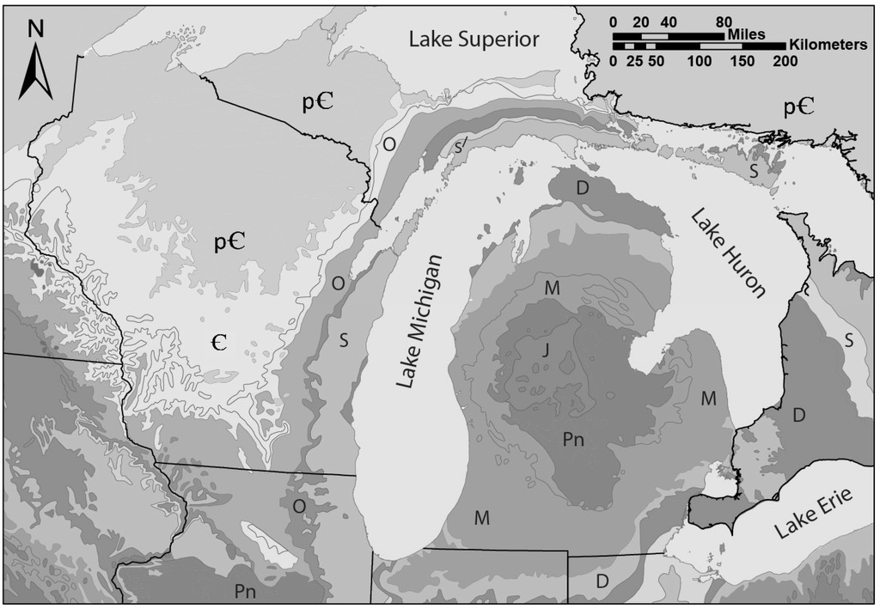
Figure 3.2. Simplified bedrock geology of the Great lakes region. Bedrock are as follows: p€ = Precambrian, € = Cambrian, O = Ordovician, S = Silurian, D = Devonian, M = Mississippian, Pn = Pennsylvanian, J = Jurassic (From: Luczaj 2013).

Figure 3.3. Concentrations in parts per million (ppm) of strontium. White bars are representative of 2014, gray are representative of 2015. Black bars represent the median values and gray and white boxes include 1st and 3rd quartile. Whiskers represent minimum and maximum values. Concentrations for MDSA were: minimum 1055.43; 1st quartile 1318.92; median 1376.3; 3rd quartile 1385.26; maximum 1415.69. Sampling locations are shown ordered beginning with mainland Wisconsin, then clockwise through the Upper Peninsula, ending in southern Michigan.

Figure 3.4. Concentrations in parts per million (ppm) of barium. White bars are representative of 2014, gray are representative of 2015. Black bars represent the median values and gray and white boxes include 1st and 3rd quartile. Whiskers represent minimum and maximum values. Sampling locations are shown ordered beginning with mainland Wisconsin, then clockwise through the Upper Peninsula, ending in southern Michigan.

Figure 3.5. Concentrations in parts per million (ppm) of magnesium. White bars are representative of 2014, gray are representative of 2015. Black bars represent the median values and gray and white boxes include 1st and 3rd quartile. Whiskers represent minimum and maximum values. Maximum value for ANTM14 was: 1264.29. Sampling locations are shown ordered beginning with mainland Wisconsin, then clockwise through the Upper Peninsula, ending in southern Michigan.

Figure 3.6. Concentrations in parts per million (ppm) of manganese. White bars are representative of 2014, gray are representative of 2015. Black bars represent the median values and gray and white boxes include 1st and 3rd quartile. Whiskers represent minimum and maximum values. Maximum value for HAYM15 was: 127.12. Sampling locations are shown ordered beginning with mainland Wisconsin, then clockwise through the Upper Peninsula, ending in southern Michigan.

Figure 3.7. The mean accuracy was calculated based on the overall classification accuracy for spatial analysis (does not include temporal analysis) and compared to the number of classification groups in each model. The spatial analysis for 2015 YOY, R4 had 5 groups (WIS, NMI, MPM, MSK, and SMI) while the fine spatial analysis for combined years had 34 groups (individual sites). See Table 2 regarding the number of classification groups in each analysis.

Figure 3.8. Average mean decrease gini values for all 70 variables (elemental chemical means) for 2014 YOY and 2015 YOY. The x-axis represents the elements included in analysis. A higher mean decrease gini value is indicative of higher importance.

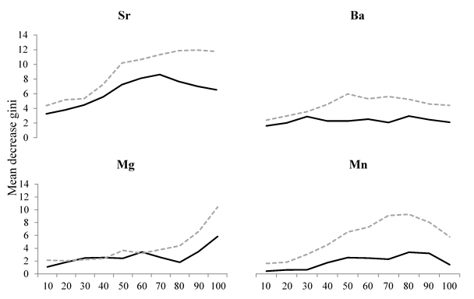

Figure 3.9. Mean decrease gini values for the top four variables of importance for 2014 (solid black line) and 2015 (gray dashed line). The x-axis represents the ablation transect. Each transect was divided into 10% increments for analysis. The y-axis represents the mean decrease gini values.
SECTION 4: EFFECTS OF INTER-ANNUAL VARIATION OF OTOLITH CHEMISTRY ON CLASSICATION ACCURACY
Introduction
A potential pitfall in using otolith microchemistry approaches is that water chemistry can vary inter-annually within a natal location. Large temporal variation may obscure spatial variation for populations comprised of multiple age classes and may diminish the use of otolith microchemistry for discriminating stocks. Indeed, recent studies have shown that otolith microchemistry of one year-class of a fish population cannot be used reliably to predict the origin of fish from other year classes (Hamer et al. 2003; Dorval et al. 2005). This issue has been demonstrated for Great Lakes fishery (Lake Erie yellow perch, Pangle et al. 2010), further supporting its potential importance to our study.
This sections describes an evaluation of how classification accuracy may be affected by inter-annual variation in otolith chemistry for Lake Michigan steelhead.

Methods
Collection, processing, and analysis of samples followed methodology described in Section 1. Collection sites included in temporal analysis were those in which YOY fish were collected in both 2014 and 2015 with n > 6 fish.
Otolith chemical signature models were developed for 2014 YOY fish (rF_2014) and 2015 YOY fish (rF_2015). Base prediction models were created using otolith data for each year to build the corresponding classification trees. Temporal classifications were then performed using the prediction models.
To predict the classifications of 2014 fish, the rF_2015 model was applied to the otolith chemical signatures of the 2014 fish using the “predict” function in the randomForest R package. Classification accuracies were calculated using the appropriate equations (CA, RCA) based upon the five spatial designations (fine, R1-4, see Section 3). Similarly, to predict the classifications of 2015 fish, the rF_2014 model was applied to the otolith chemical signatures of the 2015 fish. Classification accuracies were then calculated using the appropriate equations (CA, RCA) based upon the five spatial designations (fine, R1-4).

Results
In 2014 and 2015 there were 16 sites in which YOY fish were collected in both years (n = 160 and 163 fish, respectively). Two models were constructed using the otolith chemical data from fish from the 16 streams. Each model was applied to fish collected in the same year and analyzed using the five spatial resolutions. Classification accuracies for the 2014 model were: 72% (fine), 79% (R1), 81% (R2), 76% (R3), and 78% (R4) (Table 4). Classification accuracies for the 2015 model were: 84% (fine), 90% (R1), 91% (R2), 92% (R3), and 95% (R4) (Table 4.1).
Overall classification accuracies were lower when applying a model to otolith data from different years. When applying the 2015 model to predict the classifications for the 2014 fish, the classification accuracies were 43% (fine), 49% (R1), 54% (R2), 59% (R3), and 57% (R4) (Table 4.1). Classification groups with 100% accuracy were TWND (fine), SJO (R1), SJO (R2), and NMI (R3) (Table 4.2). No classification group in R4 had 100% classification accuracy.
Accuracy was slightly better when applying the 2014 model to predict the classifications for the 2015 fish, with classification accuracies of 55% (fine), 63% (R1), 65% (R2), 64% (R3), and 66% (R4) (Table 4.1). Classification groups with 100% accuracy were HIBB and KIDS (fine), TVC (R1), and NMI (R3) (Table 4.3). No classification group in R2 or R4 had 100% classification accuracy.

Table 4.1. Classification accuracies for temporal analysis across the five spatial scales. The 2014 and 2015 YOY analysis correspond to the models constructed using each year’s otolith chemistry data and applying the model to that years fish. The “Predict 2014” analysis uses the 2015 YOY model and applies it to the 2014 YOY fish and vice versa for the “Predict 2015” analysis.

 | Fine | Region 1 | Region 2 | Region 3 | Region 4
2014 YOY | 72% | 79% | 81% | 76% | 78%
2015 YOY | 84% | 90% | 91% | 92% | 95%
Predict 2014 | 43% | 49% | 54% | 59% | 57%
Predict 2015 | 55% | 63% | 65% | 64% | 66%

Table 4.2. Classifications based on random forest model for predicting classification of 2015 fish using the 2014 model. Sites (classification groups) are ordered based on geographic location starting with mainland Wisconsin, then through the Door Peninsula, across Michigan’s Upper Peninsula from west to east, then down through the Lower Peninsula, ending with southern Lower Peninsula sites. The gray shaded squares are representative of the number of correctly classified fish based on otolith chemistry. The far left column represents the classification group the fish was originally from. The top row represents the location to which the fish classified based upon the random forest model.
 | SAUK | HIBB | WOOD | BLCK | KIDS | BEAR | PINE | LMAN | TWIN | LSPM | MBPM | WELD | BGLW | PRRE | SLVR | TWND
SAUK | 5 | 0 | 0 | 0 | 0 | 0 | 0 | 0 | 5 | 0 | 0 | 0 | 0 | 0 | 0 | 0
HIBB | 0 | 10 | 0 | 0 | 0 | 0 | 0 | 0 | 0 | 0 | 0 | 0 | 0 | 0 | 0 | 0
WOOD | 0 | 2 | 7 | 1 | 0 | 0 | 0 | 0 | 0 | 0 | 0 | 0 | 0 | 0 | 0 | 0
BLCK | 0 | 0 | 9 | 1 | 0 | 0 | 0 | 0 | 0 | 0 | 0 | 0 | 0 | 0 | 0 | 0
KIDS | 0 | 0 | 0 | 0 | 10 | 0 | 0 | 0 | 0 | 0 | 0 | 0 | 0 | 0 | 0 | 0
BEAR | 0 | 0 | 0 | 0 | 0 | 0 | 0 | 0 | 0 | 0 | 0 | 1 | 0 | 9 | 0 | 0
PINE | 0 | 0 | 0 | 0 | 0 | 0 | 6 | 0 | 0 | 0 | 1 | 2 | 0 | 1 | 0 | 0
LMAN | 6 | 0 | 0 | 0 | 0 | 0 | 0 | 2 | 2 | 0 | 0 | 0 | 0 | 0 | 0 | 0
TWIN | 3 | 0 | 0 | 0 | 0 | 0 | 0 | 0 | 7 | 0 | 0 | 0 | 0 | 0 | 0 | 0
LSPM | 0 | 0 | 0 | 0 | 0 | 0 | 0 | 0 | 0 | 8 | 0 | 0 | 0 | 0 | 2 | 0
MBPM | 0 | 0 | 0 | 0 | 2 | 0 | 1 | 0 | 0 | 1 | 0 | 1 | 0 | 3 | 2 | 0
WELD | 0 | 0 | 0 | 0 | 0 | 3 | 2 | 0 | 0 | 1 | 1 | 2 | 0 | 0 | 1 | 0
BGLW | 1 | 0 | 0 | 0 | 0 | 1 | 1 | 2 | 0 | 0 | 0 | 0 | 5 | 0 | 0 | 0
PRRE | 0 | 0 | 0 | 0 | 0 | 0 | 1 | 0 | 0 | 0 | 0 | 0 | 0 | 12 | 0 | 0
SLVR | 0 | 0 | 0 | 0 | 0 | 0 | 0 | 0 | 0 | 2 | 0 | 0 | 0 | 0 | 8 | 0
TWND | 0 | 0 | 0 | 1 | 1 | 0 | 0 | 0 | 0 | 0 | 0 | 0 | 0 | 0 | 0 | 8

Table 4.3. Classifications based on random forest model for predicting classification of 2014 fish using the 2015 model. Sites (classification groups) are ordered based on geographic location starting with mainland Wisconsin, then through the Door Peninsula, across Michigan’s Upper Peninsula from west to east, then down through the Lower Peninsula, ending with southern Lower Peninsula sites. The gray shaded squares are representative of the number of correctly classified fish based on otolith chemistry. The far left column represents the classification group the fish was originally from. The top row represents the location to which the fish classified based upon the random forest model.
 | SAUK | HIBB | WOOD | BLCK | KIDS | BEAR | PINE | LMAN | TWIN | LSPM | MBPM | WELD | BGLW | PRRE | SLVR | TWND
SAUK | 0 | 0 | 0 | 0 | 0 | 0 | 0 | 8 | 0 | 0 | 0 | 0 | 2 | 0 | 0 | 0
HIBB | 0 | 5 | 4 | 0 | 0 | 0 | 0 | 0 | 0 | 0 | 0 | 0 | 0 | 0 | 0 | 0
WOOD | 0 | 0 | 3 | 4 | 0 | 1 | 0 | 0 | 0 | 0 | 0 | 1 | 0 | 0 | 0 | 1
BLCK | 0 | 0 | 5 | 0 | 1 | 0 | 0 | 0 | 0 | 0 | 0 | 0 | 0 | 0 | 0 | 4
KIDS | 0 | 0 | 0 | 0 | 6 | 0 | 0 | 0 | 0 | 0 | 1 | 0 | 0 | 4 | 0 | 0
BEAR | 0 | 0 | 0 | 0 | 0 | 0 | 3 | 0 | 0 | 3 | 0 | 4 | 0 | 0 | 0 | 0
PINE | 0 | 0 | 0 | 0 | 0 | 0 | 7 | 0 | 0 | 1 | 0 | 2 | 0 | 2 | 0 | 0
LMAN | 0 | 0 | 0 | 0 | 0 | 0 | 2 | 2 | 1 | 0 | 1 | 0 | 3 | 0 | 0 | 1
TWIN | 3 | 0 | 1 | 0 | 0 | 0 | 0 | 1 | 5 | 0 | 0 | 0 | 1 | 0 | 0 | 0
LSPM | 0 | 0 | 0 | 0 | 0 | 0 | 0 | 0 | 0 | 7 | 2 | 0 | 0 | 0 | 1 | 0
MBPM | 0 | 0 | 0 | 0 | 0 | 0 | 3 | 0 | 0 | 0 | 3 | 0 | 0 | 4 | 0 | 0
WELD | 0 | 0 | 0 | 0 | 0 | 0 | 4 | 0 | 0 | 0 | 1 | 4 | 0 | 0 | 0 | 0
BGLW | 0 | 0 | 0 | 0 | 2 | 0 | 1 | 1 | 0 | 0 | 0 | 0 | 6 | 0 | 0 | 0
PRRE | 0 | 0 | 0 | 0 | 0 | 0 | 0 | 0 | 0 | 0 | 4 | 0 | 0 | 3 | 0 | 0
SLVR | 0 | 0 | 0 | 0 | 0 | 0 | 0 | 0 | 0 | 3 | 0 | 0 | 0 | 0 | 8 | 0
TWND | 0 | 0 | 0 | 0 | 0 | 0 | 0 | 0 | 0 | 0 | 0 | 0 | 0 | 0 | 0 | 10

SECTION 5: A COMPARISON OF CLASSIFICATION ACCURACY USING THE OTOLITH CHEMISTRY OF YOY vs. YAO STEELHEAD

Introduction
We compared classification accuracy using the otolith chemistry of YOY vs. YAO steelhead. We hypothesized that YAO fish will have a more distinct signature of their natal location because of their longer duration in the stream; however, we also considered an alternative hypothesis that age-1 fish will have a less distinct signature due to the fact that juvenile steelhead are known to move within a watershed, particularly over their first winter (Sheppard and Johnson 1985, Leider et al. 1986), and individual variation in this movement may add to variability associated with a general tributary signature. From a practical standpoint, we also considered effort required to sample each age class.

Methods
Collection, processing, and analysis of samples followed methodology described in Section 1. Collection sites included in the comparison were those in which both YOY and YOA fish were collected in 2014 and 2015. We evaluated accuracy at the finest spatial resolution (see Section 3).

Results
In 2014, mean classification accuracy for YOY and YAO fish was 80 and 78%, respectively. In 2015, mean classification accuracy for YOY and YAO fish was 86 and 79%, respectively. On average, it required approximately half the effort (person hours) to sample the same number of YOY fish relative to YAO fish.

SECTION 6: RELATIONSHIPS BETWEEN TRIBUTARY WATER CHEMISTRY AND STEELHEAD OTOLITH CHEMISTRY

Introduction
We examined spatial patterns the tributary water chemistry across the Lake Michigan basin and related these patterns to those observed for steelhead otolith chemistry. We focused on the four elements found most important in our otolith chemistry analysis (see Section 3). These included barium, magnesium, manganese, and strontium.

Methods
Collection, processing, and analysis of fish samples followed methodology described in Section 1. Water samples were taken at sites in which fish were collected, including Thompson and Wolf Lake hatcheries, and immediately fixed with 2% ultra-pure nitric acid. Elemental concentrations were measure by the STAR (Speciation-Traces-Analyses-Radioisotopes) lab at Central Michigan University under the supervision of Dr. Anthony Chappaz using an ICP-MS.

Results
Tributary water chemistry varied strongly across the Lake Michigan basin (Figures 6.1-6.4). Spatial clustering was apparent in the concentrations of all four elements such that tributaries in close proximity to one another tended to have similar chemistry.
The relationship between the elemental concentrations in the tributary and steelhead otoliths was remarkably poor (Figures 6.5-6.8). The exception was that observed for strontium (Figure 6.8), for which water and otolith chemistry were strongly correlated (R² = 0.82).

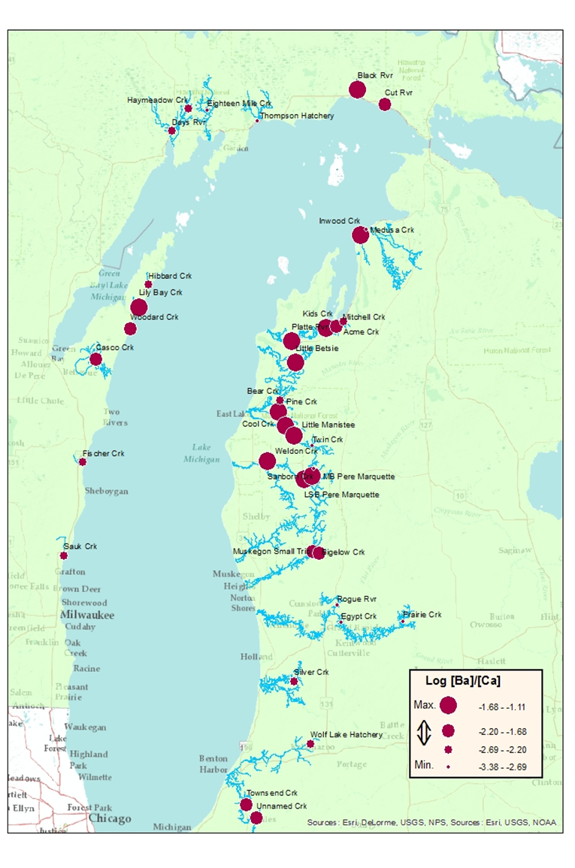
Figure 6.1. Molar ratios of barium (Ba) to calcium (Ca) of stream water at sample sites. Circles indicate site locations, and their diameters are proportion to the natural log of the ratio.
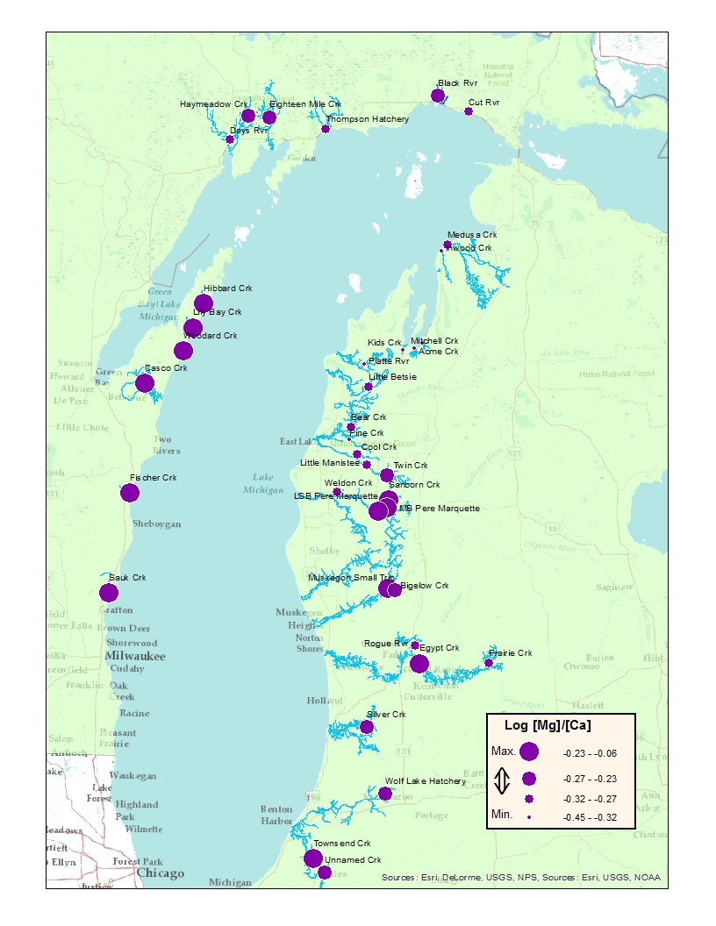
Figure 6.2. Molar ratios of magnesium (Mg) to calcium (Ca) of stream water at sample sites. Circles indicate site locations, and their diameters are proportion to the natural log of the ratio.

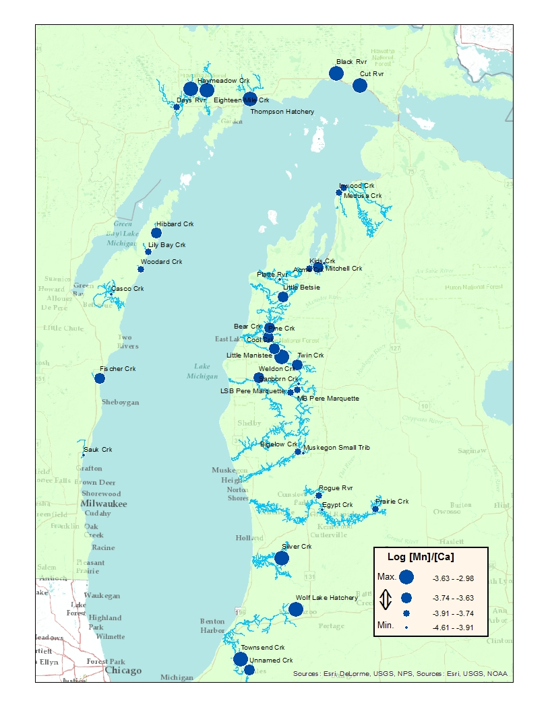
Figure 6.3. Molar ratios of manganese (Mn) to calcium (Ca) of stream water at sample sites. Circles indicate site locations, and their diameters are proportion to the natural log of the ratio.

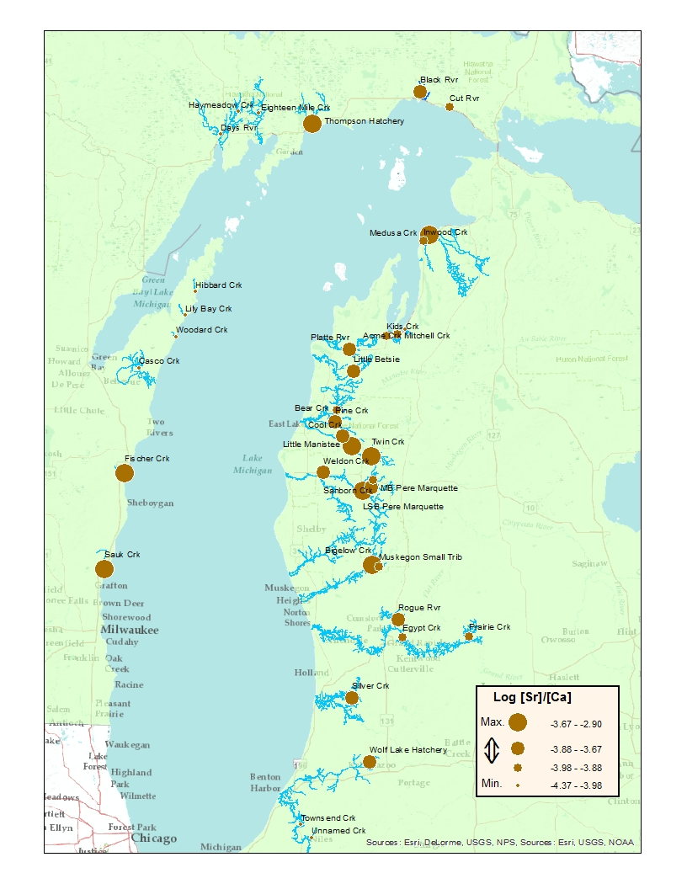
Figure 6.4. Molar ratios of strontium (Sr) to calcium (Ca) of stream water at sample sites. Circles indicate site locations, and their diameters are proportion to the natural log of the ratio.

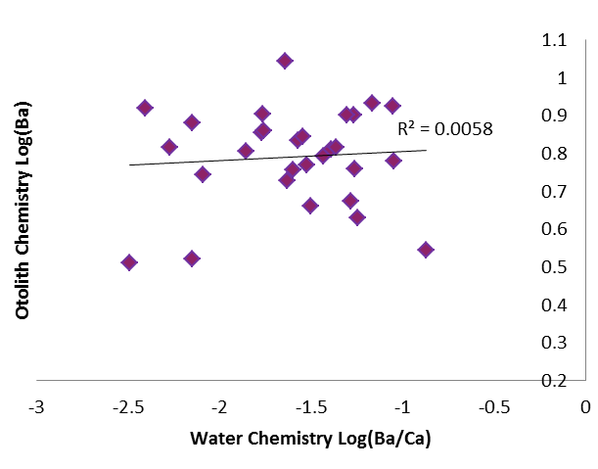

Figure 6.5. The relationship between the log of molar ratio of barium (Ba) to calcium (Ca) of stream water vs the log of mean Ba concentrations measured in steelhead otoliths at each collection site.

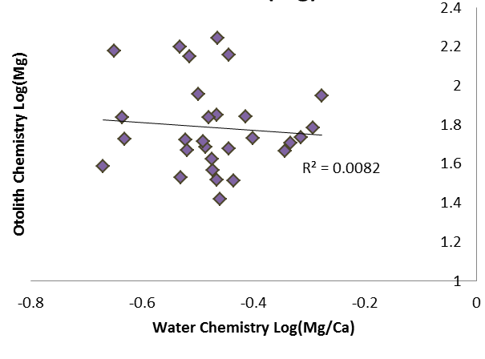
Figure 6.6. The relationship between the log of molar ratio of magnesium (Mg) to calcium (Ca) of stream water vs the log of mean Mg concentrations measured in steelhead otoliths at each collection site.

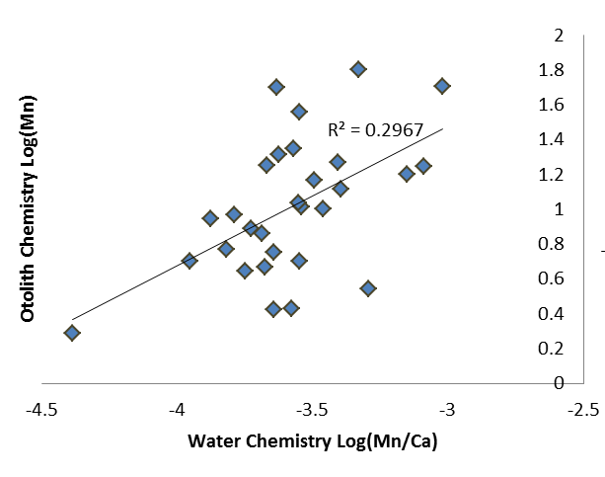

Figure 6.7. The relationship between the log of molar ratio of manganese (Mn) to calcium (Ca) of stream water vs the log of mean Mn concentrations measured in steelhead otoliths at each collection site.

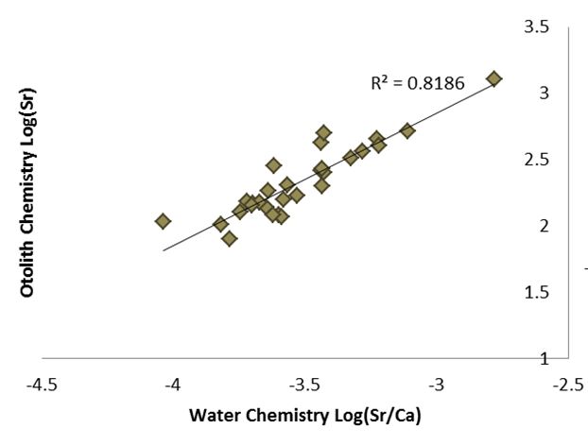

Figure 6.8. The relationship between the log of molar ratio of strontium (Sr) to calcium (Ca) of stream water vs the log of mean Sr concentrations measured in steelhead otoliths at each collection site.

SECTION 7: PROJECT CONCLUSIONS AND IMPLICATIONS

Hatchery differentiation

Discrimination of stocked and wild conspecifics is a common fisheries management concern (e.g., Johnson et al. 2010; Schröder and Garcia de Leaniz 2011; Hinrichsen et al. 2016). For many fisheries comprised of both wild- and hatchery-origin fish, management agencies differentiate wild and stocked fish in many ways, including fin clipping, internal and external tagging, and chemical marking (e.g., oxytetracycline marking) (McFarlane et al. 1990; Pine et al. 2012). However, accurate quantification of the proportion of a fishery derived from stocked fish requires marking all stocked fish each year, and such an undertaking may not be feasible for various reasons. Fin clipping and tagging may not be viable for early life stages or small fish sizes, and the cost and labor required to mark all fish may be prohibitive (Hammer and Blankenship 2001).

Alternatively, fish origin may be determined through analysis of characteristics imparted differentially upon fish occupying either hatcheries or natural environments. For example, growth pattern analyses have been developed for scales (Seelbach and Whelan 1988) and fin spines (Siegwarth 1994) to differentiate between wild- and hatchery-origin fish. More recently, analysis of fish otolith microchemical signatures has become a primary tool for reconstructing fish environmental histories (Campana 1999; Campana and Thorrold 2001; Pracheil et al. 2014). Briefly, the incorporation of various trace elements into the calcium carbonate matrix of otoliths is related to both the availability of these elements in the environment and physicochemical properties of the water in which fish reside (Campana and Thorrold 2001; Elsdon et al. 2008; Sturrock et al. 2014). Thus, diagnostic differences in otolith trace elemental concentrations may arise given sufficient differences in the properties governing trace element uptake among sites (Wells et al. 2003; Pangle et al. 2010; Schoen et al. 2016). Importantly, for distinguishing between wild and stocked fish, otolith microchemical analysis may overcome common limitations of fish marking programs because this methodology has successfully been applied to fish as young as the larval life stage (Pangle et al. 2010; Reichert et al. 2010), and costs are only expended on fish analyzed.

Both wild- and hatchery-origin steelhead, the anadromous form of Rainbow Trout Oncorhynchus mykiss, are important components of a world-class, multi-species, recreational salmonine fishery throughout Lake Michigan and its tributaries – representing millions of dollars of value to the region (Tanner and Tody 2002; Tsehaye et al. 2014; Clark et al. 2016). The contemporary Lake Michigan steelhead fishery is supplemented with annual plantings of more than one million juvenile steelhead, raised at five hatcheries among the states of Illinois, Indiana, Michigan, and Wisconsin. Nonetheless, wild, naturally-reproduced steelhead have long comprised a considerable proportion of the total steelhead population (Tody and Tanner 1966; Seelbach and Whelan 1988; Bartron et al. 2004). Most of the steelhead stocked within the Lake Michigan basin are not marked by any means, thus otolith chemical analysis may constitute a cost-effective means of determining the origins of unmarked steelhead in this population. Such information may provide valuable insights as to the effectiveness of the multi-state juvenile steelhead stocking program relative to fishery management objectives.

Our results support other studies that have found otolith chemical analysis has proven to be an effective tool for distinguishing hatchery and wild origin young fish (Coghlan et al. 2007; Gibson-Reinemer et al. 2009; Zitek et al. 2010), and demonstrates the utility of otolith chemical analysis as a tool for this purpose with steelhead in the Great Lakes region. This type of analysis could be applied to adult steelhead to estimate the stock composition of the entire lake population, as well as returns to tributaries. Given our success in differentiating hatchery- and wild-origin steelhead from among many Lake Michigan tributaries, it is possible that similar techniques would work for other fish species where both hatchery-reared and wild fish cohabitate.

To further improve discrimination between wild and hatchery origin stocks, otolith chemical differences could be considered when selecting stocking sources. The use of fish from a hatchery with distinct differences in otolith chemistry from that of the wild-origin fish would provide improved differentiation between the two stocks post-stocking. Thompson Creek Fish Hatchery utilizes water obtained from a deep aquifer with high levels of strontium resulting in high Sr levels in otoliths of fish reared at the facility. This provides a distinct otolith chemistry allowing for high levels of accuracy in determination of fish obtained from this hatchery. In the event that discrimination is found to be poor between a stocking source and the wild conspecifics, supplementation of fish from an alternate source may improve these results with future stocking events. Whenever possible, stocking sources with unique water chemistries as compared to the natural stream should be used.

Elemental concentrations
A critical factor in using elemental concentrations derived from otoliths is variation between classification groups whether at the stream or regional level. We found Sr to have the highest variability between sites in our study. These results were consistent with Pangle et al. (2010) showing differences in Sr concentrations between sampling locations in the Lake Erie watershed. Differences in Sr concentrations in the otoliths appear to have a regional basis likely attributed to geologic influences due to composition of bedrock and surficial geology and incorporation of elements into the water through erosion (Hegg et al. 2003; Rondeau et al 2005; Pangle et al. 2010; Marklevitz et al 2011). Medusa Creek had the highest mean Sr concentration (1,322.33 ± 122.466 ppm). The elevated Sr levels in Medusa Creek may be attributed to strong anthropogenic influences on the system as this man-made stream acts as a drainage for the limestone quarries of the St. Marys Cement plant in Charlevoix, MI. Skougstad and Horr (1963) found elevated Sr concentrations in groundwater associated with limestone and glacial deposits during the Late Silurian. Hibbards Creek had the lowest mean Sr concentrations in both years and levels were similar for Woodard Creek, as these sites are both in the Door Peninsula, WI these low levels are also likely attributed to regional effects due to geology.
Concentrations of Cu exhibited inter-annual differences for the Black River, Sauk Creek, Bigelow Creek, and Woodard Creek. Both Black and Sauk had lower Cu levels in 2014 and higher Cu levels in 2015. The opposite is true for Bigelow and Woodard Creeks with higher levels in 2014 and lower in 2015. The cause of this is not known and little research has been done on fluctuations in Cu concentrations in fish otoliths. Miller et al. (2006) found Cu and Zn were associated with the protein matrix of otoliths and concentrations of Cu are not reliable indicators of environmental exposure. We found that concentrations of Zn did not vary greatly between sites and was not a top predictor variable of importance. This may be due to the highly regulated nature of Zn uptake in teleost fish (Gibson-Reinemer et al. 2009). Manganese concentrations varied slightly between sites with the exception of three sites in the western region of Michigan’s Upper Peninsula in 2015 having elevated concentrations compared to others: Eighteen Mile Creek, Days River, and Haymeadow Creek (Figure 7). All three of these sites are in close geographical proximity to each other which could provide insight to their similarity. In 2014, the Black River had higher overall Mn concentrations and this site is also in the Upper Peninsula (Figure 7). Mn was one of the top four predictor variables of importance in our models, and has been found to be important to discrimination in differentiation of fish populations (Brazner et al 2004a, 2004b; Coghlan et al. 2007; Bradbury et al. 2008). The variances in elemental concentrations occurring between sites have shown to provide useful predictor variables in otolith chemical analysis.

Spatial Analysis
We have demonstrated the ability to classify juvenile fish using fine scale spatial resolution to stream of origin based on otolith chemical analysis in three classification models with relatively high accuracy, 86% accuracy for 2014 YOY, 75% accuracy for 2015 YOY, and 79% accuracy for the combined year model. Many of the misclassifications that occurred were to neighboring streams such as in the 2014 YOY model (Figure 8) in which one fish from Twin Creek classified as Little Manistee. Similar misclassifications occurred with the 2015 YOY model (Figure 9) where one fish originating from Fischer Creek classified as Sauk Creek and two fish from the Cut River classified as Black River. Other misclassifications occurred to streams having similar geologic features and chemical means. These results are consistent with the findings of Pangle et al. (2010) and Marklevitz et al. (2011) who also found misclassifications occurred to nearby streams or regions.
The implementation of regional classification groupings increased our classification accuracy to as high as 93%. Classification accuracy increased as the number of classification groups decreased (Figure 11) stressing the importance of understanding factors contributing to regional assignments. When assigning regional classification groups, it is critical to consider the important role geological processes play in influencing otolith chemistry (Marklevitz et al. 2011). We chose to run a regional analysis using four spatial scales in which sites were grouped based on spatial proximity and similar geologic features. Regional classifications R1 and R2 had lower accuracies than those in R3 and R4 (Table 4). Classification accuracies peaked with the R3 regional classification which represented a moderately coarse level of classification. For the 2014 YOY, 2015 YOY, and combined year models accuracies were 92%, 92%, and 93%, respectively. The R3 regional classification consists of seven groups: Wisconsin, Michigan Upper Peninsula, northern Michigan, Medusa Creek, Manistee and Pere Marquette, Muskegon River, and southern Michigan. We elected to keep Medusa Creek separate on all spatial scales due to its unique otolith chemistry. We chose to run our spatial analysis in a manner that maintained the integrity of the unique otolith signatures for each stream within regional classification groups. Our results demonstrate the effectiveness of otolith chemical analysis in the discrimination of origins for juvenile Steelhead.
The Manistee and Pere Marquette watersheds are thought to be primary contributors to the overall steelhead population in Lake Michigan (Seelbach and Whelan 1988; Seelbach 1993; Tyler and Rutherford 2007; Woldt and Rutherford 2002). When including only on these two watersheds in analysis, fine scale classification accuracy for 2014 and 2015 was 88% and 74%, respectively. R1 classification for 2014 and 2015 improved with accuracies of 88% and 85%, respectively. A coarser spatial resolution, R2, for 2014 and 2015 had similar results with accuracies of 88% and 87%, respectively. As with the full classification model, misclassifications at the fine scale are the results of fish classifying into neighboring streams. These watersheds can be differentiated at the watershed (R1 and R2) regional classification levels.

Temporal Analysis
Highest accuracies in temporal analysis corresponded to R2 and R4 spatial scales, 65% and 66%, respectively, and both associated with the “predict 2015” model. This model used classification trees constructed with the 2014 otolith model and applied it to the 2015 otolith chemistry data. Accuracies were lowest at fine scale spatial resolution, which is consistent with other research using elemental concentrations (Pangle et al. 2010; Marklevitz et al. 2011). Misclassifications occurred to neighboring streams/regions but also to streams with similar elemental composition or temporal fluctuations in chemistry. Temporal variability may be attributed to seasonal fluctuations in elements such as Sr (Bacon et al. 2004). A particular misclassification that occurred in the prediction models occurred between Woodard Creek and Black River. In the “predict 2014” model, nine fish from Black River misclassified to Woodard Creek and one Woodard Creek fish misclassified as Black River. In the “predict 2015” model, five fish from Black River misclassified to Woodard Creek and four Woodard Creek fish misclassified as Black River. Interestingly, Cu concentrations exhibited a fluctuation for Black River and Woodard Creek with Black having higher concentrations in 2015 and lower in 2014 and Woodard having higher concentrations in 2014 and lower in 2015. The change in Cu concentration may explain the misclassifications for these two site between the two years of data. Although we did not have results with nearly as high of classification accuracies as with the spatial analysis, a regional classification application of the otolith chemical analysis does show promise in providing a useful tool for discrimination. Dove and Kingsford (1998) found Sr to be a more temporally stable element. The variation in Sr concentration across sites may prove increasingly beneficial across a temporal scale. The findings of Miller et al. (2006) regarding Cu and Zn being unreliable indicators due to their association with the otolith protein matrix and as Cu may have confounded the classification accuracies in temporal modelling, it may prove beneficial to consider the omission of one or both elements in future temporal analyses.

Variables of Importance
Strontium was found to be the predictor variable of highest importance for both years based on mean decrease gini values. Ba, Mg, and Mn were also found to be important variables. These results are consistent with the findings from other studies in which Sr, Mn, and Ba, or a combination of, have been found as elements useful in discrimination (e.g., Pangle et al. 2010; Mercier et al. 2011; Marklevitz et al. 2011; Boehler et al. 2012). The importance of Sr and Ba in discrimination may be due to the ease of substitution into the crystalline matrix through passive transport as both Sr and Ba have similar ionic properties as Ca (Campana 1999). Additionally, previous work has found water chemistry, not diet, being the primary factor for incorporation into the otolith (Gillanders 2005; Gibson-Reinemer et al. 2009). This reiterates the importance of water chemistry, rather than differences in the prey biota, in otolith chemical analysis.

Additional Implications
We have demonstrated high accuracy in classification to stream/region of origin on five spatial scales. Sites with high classification accuracy are known producers of wild fish. Our results are consistent with Marklevitz et al. (2011) which tested the utilization of otolith chemistry to discriminate natal origins of Chinook salmon in the Great Lakes. The results of our study show the ability to classify on a finer classification scale. This may be attributed to steelhead residing in natal streams for a longer period of time than Chinook salmon.
Based upon the results of this study, it is very plausible that otolith chemical analysis of adult steelhead could be used to identify sources of natural reproduction and quantify relative contributions of stream-specific recruitment among tributaries of Lake Michigan This, in turn, will help direct conservation and management to areas that are major contributors to the total population, provide insight to wild fish contribution, and allow for adjustments of stocking levels.

SECTION 8: PRESENTATIONS AND MANUSCRIPTS IN PREPARATION

Presentations
2014: MDNR Lake Michigan Basin Team (July)

2015: Saint Joseph River Valley Fly Fishers (March)
Annual Conference of the International Association of Great Lakes Research (May)
St. Joseph River Basin Commission Symposium (May)
Michigan DNR combined Lake Huron and Lake Michigan Basin Team Meeting (July)
Annual Conference of American Fisheries Society (August)
Lake Michigan Citizen’s Fishery Advisory Committee Meeting (September)

2016: Annual Midwest Fish and Wildlife Conference (January)
Ann Arbor Trout Unlimited (March)
Gary Borger Chapter Trout Unlimited (April)
Annual Conference of the International Association for Great Lakes Research (June)
Saint Joseph River Valley Fly Fishers (September)
Duneland Fly Fishers, Valparaiso University (November)

2017: Lake Michigan Tech Committee Meeting (January)
Lake Michigan Basin Team Meeting (February)

Manuscript in preparation

Watson, N. M., C. G. Prichard, J. L. Jonas, J. J. Student, and K. L. Pangle. Otolith chemistry-based classification of wild and hatchery juvenile steelhead (Oncorhynchus mykiss) across the Lake Michigan basin. In preparation for the North American Journal of Fisheries Management.

Watson, N. M., C. G. Prichard, J. L. Jonas, J. J. Student, and K. L. Pangle. Spatiotemporal variation in otolith chemistry of juvenile steelhead (Oncorhynchus mykiss) across the Lake Michigan basin. In preparation for the Canadian Journal of Fisheries and Aquatic Sciences.

Publication

Watson, N., Wild. Dun Magazine, Fall 2015.
The paper earned the 2016 American Fisheries Society Student Writing Contest award.

SECTION 9: LITERATURE CITED
Alexander, R. B., Slack, J. R., Ludtke, A. S., Fitzgerald, K. K., and Schertz, T. L. 1996. Data from selected U.S. Geological Survey National Stream Water-Quality Monitoring Networks (WQN). USGS Digital Data Series DDS-37.
Bacon, C. R., Weber, P. K., Larsen, K. A., Reisenbichler, R., Fitzpatrick, J. A., and Wooden, J. L. 2004. Migration and rearing histories of chinook salmon (Oncorhynchus tshawytscha) determined by ion microprobe Sr isotope and Sr/Ca transects of otoliths. Canadian Journal of Fisheries and Aquatic Sciences, 61(12), 2425-2439.
Barton, M. L., Swank, D. R., Rutherford, E. S., and Scribner, K. T. 2004. Methodological bias in estimates of strain composition and straying of hatchery-produced steelhead in Lake Michigan tributaries. North American Journal of Fisheries Management, 24, 1288-1299.
Bataille, C. P., and Bowen, G. J. 2012. Mapping ⁸⁷Sr/⁸⁶Sr variations in bedrock and water for large scale provenance studies. Chemical Geology, 304, 39-52.
Boehler, C. T., Miner, J. G., Farver, J. R., and Fryer, B. J. 2012. Within-stream release-site fidelity of steelhead trout from Lake Erie hatchery stocks. Journal of Great Lakes Research, 38(2), 251-259.
Bradbury, I. R., Campana, S. E., and Bentzen, P. 2008. Otolith elemental composition and adult tagging reveal spawning site fidelity and estuarine dependency in rainbow smelt. Marine Ecology Progress Series, 368, 255-268.
Brazner, J. C., Campana, S. E., Tanner, D. K., and Schram, S. T. 2004a. Reconstructing habitat use and wetland nursery origin of yellow perch from Lake Superior using otolith elemental analysis. Journal of Great Lakes Research, 30(4), 492-507.
Brazner, J. C., Campana, S. E., and Tanner, D. K. 2004b. Habitat fingerprints for Lake Superior coastal wetlands derived from elemental analysis of yellow perch otoliths. Transactions of the American Fisheries Society, 133(3), 692-704.
Breiman, L. 2001. Random forests. Machine Learning 45:5-32.
Brennan, S. R., Fernandez, D. P., Zimmerman, C. E., Cerling, T. E., Brown, R. J., and Wooller, M. J. 2015. Strontium isotopes in otoliths of a non-migratory fish (slimy sculpin): Implications for provenance studies. Geochimica et Cosmochimica Acta, 149, 32-45.
Campana, S. E. 1999. Chemistry and composition of fish otoliths: pathways, mechanisms and applications. Marine Ecology Progress Series, 188, 263-297.
Campana, S. E., and Neilson, J. D. 1985. Microstructure of fish otoliths. Canadian Journal of Fisheries and Aquatic Sciences, 42(5), 1014-1032. Chicago
Campana, S. E., and Thorrold, S. R. 2001. Otoliths, increments, and elements: keys to a comprehensive understanding of fish populations? Canadian Journal of Fisheries and Aquatic Sciences, 58(1), 30-38.
Carlander, K. D. 1969. Handbook of freshwater fishery biology. Volume 1. Life history data on freshwater fishes of the United States and Canada, exclusive of the Perciformes.
Coghlan Jr, S. M., Lyerly, M. S., Bly, T. R., Williams, J. S., Bowman, D., and Hannigan, R. 2007. Otolith chemistry discriminates among hatchery-reared and tributary-spawned salmonines in a tailwater system. North American Journal of Fisheries Management, 27(2), 531-541.
Creque, S. M., Rutherford, E. S., and Zorn, T. G. 2005. Use of GIS-derived landscape-scale habitat features to explain spatial patterns of fish density in Michigan rivers. North American Journal of Fisheries Management, 25(4), 1411-1425.
Dorval, E., Jones, C.M., Hannigan, R., and van Montfrans, J. 2005. Can otolith chemistry be used for identifying essential seagrass habitats for juvenile spotted seatrout, Cynoscion nebulosus, in Chesapeake Bay? Marine and Freshwater Research 56(5): 645–653.
Dove, S. G., and Kingsford, M. J. 1998. Use of otoliths and eye lenses for measuring trace-metal incorporation in fishes: a biogeographic study. Marine Biology, 130(3), 377-387.
Einum, S., and Fleming, I. A. 2001. Implications of stocking: ecological interactions between wild and released salmonids. Nordic Journal of Freshwater Research, 75, 56-70.
Elsdon, T. S., Wells, B. K., Campana, S. E., Gillanders, B. M., Jones, C. M., Limburg, K. E., and Walther, B. D. 2008. Otolith chemistry to describe movements and life-history parameters of fishes: hypotheses, assumptions, limitations and inferences. Oceanography and marine biology: an annual review, 46(1), 297-330.
Engstedt, O., Stenroth, P., Larsson, P., Ljunggren, L., and Elfman, M. 2010. Assessment of natal origin of pike (Esox lucius) in the Baltic Sea using Sr:Ca in otoliths. Environmental Biology of Fishes, 89, 547-555.
Gibson-Reinemer, D. K., Johnson, B. M., Martinez, P. J., Winkelman, D. L., Koenig, A. E., and Woodhead, J. D. 2009. Elemental signatures in otoliths of hatchery rainbow trout (Oncorhynchus mykiss): distinctiveness and utility for detecting origins and movement. Canadian Journal of Fisheries and Aquatic Sciences, 66(4), 513-524.
Gillanders, B. M. 2005. Using elemental chemistry of fish otoliths to determine connectivity between estuarine and coastal habitats. Estuarine, Coastal and Shelf Science, 64(1), 47-57.
Godby Jr, N. A., Rutherford, E. S., and Mason, D. M. 2007. Diet, feeding rate, growth, mortality, and production of juvenile steelhead in a Lake Michigan tributary. North American Journal of Fisheries Management, 27(2), 578-592.
Hamer, P.A., Jenkins, G.P., and Gillanders, B.M. 2003. Otolith chemistry of juvenile snapper Pagrus auratus in Victorian waters: natural chemical tags and their temporal variation. Marine Ecology Progress Series 263: 261–273.
Hammer, S. A., and Blankenship, H. L. 2001. Cost comparison of marks, tags, and mark-with-tag combinations used in salmonid research. North American Journal of Aquaculture, 63, 171-178.
Hand, C. P., Ludsin, S. A., Fryer, B. J., and Marsden, J. E. 2008. Statolith microchemistry as a technique for discriminating among Great Lakes sea lamprey (Petromyzon marinus) spawning tributaries. Canadian Journal of Fisheries and Aquatic Sciences, 65(6), 1153-1164.
Hegg, J. C., Kennedy, B. P., and Fremier, A. K. 2013. Predicting strontium isotope variation and fish location with bedrock geology: Understanding the effects of geologic heterogeneity. Chemical Geology, 360, 89-98.
Hellstrom, J., Paton, C., Woodhead, J.D. and Hergt, J.M. 2008. Iolite: software for spatially resolved LA-(quad and MC) ICPMS analysis. In Laser Ablation ICP–MS in the Earth Sciences: Current Practices and Outstanding Issues (P. Sylvester, ed.). Mineralogical Association of Canada Short Course series 40, 343-348.
Hinrichsen, R. A., Steele, C. A., Ackerman, M. W., Campbell, M. R., Narum, S. R., Hess, M. A., Young, W. P., Shields, B. A., Nez Perce Tribe, and Maschoff, B. L. 2016. Maximum likelihood estimation of the proportion of hatchery-origin fish on spawning grounds using coded wire tagging and parentage-based tagging. Transactions of the American Fisheries Society, 145, 671-686.
Hirethota, P. S., and Burzynski, T. E. 2015. Natural reproduction of salmonids in Lake Michigan tributaries of Wisconsin. Wisconsin Department of Natural Resources, Southern Lake Michigan Fisheries Team Report, Milwaukee.
Hummel, S. M. 2014. Using otolith chemistry to detect trace element signatures in juvenile Steelhead (Oncorhynchus mykiss) from Lake Michigan tributaries (Master's thesis). Central Michigan University, Mount Pleasant, Michigan.
Jochum, K. P., Nohl, U., Herwig, K., Lammel, E., Stoll, B., and Hofmann, A. W. 2005. GeoReM: a new geochemical database for reference materials and isotopic standards. Geostandards and Geoanalytical Research, 29(3), 333-338.
Johnson, J. E., DeWitt, S. P., and Gonder, D. J. 2010. Mass-marking reveals emerging self regulation of the salmon population in Lake Huron. North American Journal of Fisheries Management, 30, 518-529.
Leider, S. A., Chilcote, M. W., and Loch, J. J. 1986. Movement and survival of presmolt steelhead in a tributary and the main stem of a Washington river. North American Journal of Fisheries Management, 6, 526–531.
Liaw, A., and Wiener, M. 2002. Classification and regression by randomForest. R News 2:18-22.
Ludsin, S. A., Fryer, B. J., and Gagnon, J. E. 2006. Comparison of solution-based versus laser ablation inductively coupled plasma mass spectrometry for analysis of larval fish otolith microelemental composition. Transactions of the American Fisheries Society, 135(1), 218-231.
Marklevitz, S. A., Fryer, B. J., Gonder, D., Yang, Z., Johnson, J., Moerke, A., and Morbey, Y. E. 2011. Use of otolith chemistry to discriminate juvenile Chinook salmon (Oncorhynchus tshawytscha) from different wild populations and hatcheries in Lake Huron. Journal of Great Lakes Research, 37(4), 698-706.
McFarlane, G. A., Wydoski, R. S., and Prince, E. D. 1990. Historical review of the development of external tags and marks. American Fisheries Society Symposium, 7, 9-29.
Mercier, L., Darnaude, A. M., Bruguier, O., Vasconcelos, R. P., Cabral, H. N., Costa, M. J., Lara, M., Jones, D. L., and Mouillot, D. 2011. Selecting statistical models and variable combinations for optimal classification using otolith microchemistry. Ecological Applications, 21(4), 1352-1364.
Miller, J. A., and Kent, A. J. R. 2009. The determination of maternal run time in juvenile Chinook Salmon (Oncorhynchus tshawytscha) based on Sr/Ca and ⁸⁷Sr/⁸⁶Sr within otolith cores. Fisheries Research, 95, 373-378.
Miller, M. B., Clough, A. M., Batson, J. N., and Vachet, R. W. 2006. Transition metal binding to cod otolith proteins. Journal of Experimental Marine Biology and Ecology, 329(1), 135-143.

Newcomb, T. J., and Coon, T. G. 1997. Environmental variability and survival of steelhead parr in a thermally diverse watershed. Michigan Department of Natural Resources, Fisheries Division. Fisheries Research Report 2046.
Pangle, K. L., Ludsin, S. A., and Fryer, B. J. 2010. Otolith microchemistry as a stock identification tool for freshwater fishes: testing its limits in Lake Erie. Canadian Journal of Fisheries and Aquatic Sciences, 67(9), 1475-1489.
Pine, W. E., Hightower, J. E., Coggins, L. G., Lauretta, M. V., and Pollock, K. H. 2012. Design and analysis of tagging studies. Pages 521-572 in A. V. Zale, D. L. Parrish, and T. M. Sutton, editors. Fisheries techniques, third edition. American Fisheries Society, Bethesda, Maryland.
Pracheil, B. M., Hogan, J. D., Lyons, J., and McIntyre, P. B. 2014. Using hard-part microchemistry to advance conservation and management of North American freshwater fishes. Fisheries, 39, 451-465.
Rand, P. S., Stewart, D. J., Seelbach, P. W., Jones, M. L., and Wedge, L. R. 1993. Modeling steelhead population energetics in Lakes Michigan and Ontario. Transactions of the American Fisheries Society, 122, 977–1001.
Reichert, J. M., Fryer, B. J., Pangle, K. L., Johnson, T. B., Tyson, J. T., Drelich, A. B., and Ludsin, S. A. 2010. River-plume use during the pelagic larval stage benefits recruitment of a lentic fish. Canadian Journal of Fisheries and Aquatic Sciences, 67, 987-1004.
Rondeau, B., Cossa, D., Gagnon, P., Pham, T. T., and Surette, C. 2005. Hydrological and biogeochemical dynamics of the minor and trace elements in the St. Lawrence River. Applied Geochemistry, 20(7), 1391-1408.
Rutherford, E. 1997. Evaluation of natural reproduction, stocking rates, and fishing regulations for steelhead Oncorhynchus mkiss, Chinook Salmon O. tschawytscha, and Coho Salmon in Lake Michigan. Michigan Department of Natural Resources, Fisheries Division, Final Report, Project F-35-R-22, Ann Arbor.
Sayers Jr, R. E. 1987. Effects of freezing in and out of water on length and weight of Lake Michigan bloaters. North American Journal of Fisheries Management, 7(2), 299-301.
Schoen, L. S., Student, J. J., Hoffman, J. C., Sierzen, M. E., and Uzarski, D. G. 2016. Reconstructing fish movements between coastal wetland and nearshore habitats of the Great Lakes. Limnology and Oceanography, 61, 1800-1813.
Schröder, V., and Garcia de Leaniz, C. 2011. Discrimination between farmed and free-living invasive salmonids in Chilean Patagonia using stable isotope analysis. Biological Invasions, 13, 203-213.
Secor, D.H. 1992. Application of otolith microchemistry analysis to investigate anadromy in Chesapeake Bay striped bass Morone saxatilis. Fisheries Bulletin (Washington, D.C.), 90, 798–806.
Seelbach, P. W. 1993. Population biology of steelhead in a stable-flow, low-gradient tributary of Lake Michigan. Transactions of the American Fisheries Society, 122(2), 179-198.
Seelbach, P. W., and Whelan, G. E. 1988. Identification and contribution of wild and hatchery steelhead stocks in Lake Michigan tributaries. Transactions of the American Fisheries Society, 117(5), 444-451.
Sheppard, J. D., and Johnson, J. H. 1985. Probability-of-use for depth, velocity, and substrate by subyearling coho salmon and steelhead trout in Lake Ontario tributary streams. North American Journal of Fisheries Management, 5, 391–403.
Siegwarth, G. L. 1994. Identification of hatchery-reared Channel Catfish by means of pectoral spine cross sections. Transactions of the American Fisheries Society, 123, 830-834.
Skougstad, M. W., and Albert, H. C. 1963. Occurrence and distribution of strontium in natural water (No. 1496-D). US Govt. Print. Off.
Stauffer, T. M. 1972. Age, growth, and downstream migration of juvenile rainbow trout in a Lake Michigan tributary. Transactions of the American Fisheries Society, 101, 18-28.
Sturrock, A. M., Trueman, C. N., Milton, J. A., Waring, C. P., Cooper, M. J., and Hunter, E. 2014. Physiological influences can outweigh environmental signals in otolith microchemistry research. Marine Ecology Progress Series, 500, 245-264.
Talheim, D. R. 1987. Economics of Great Lakes fisheries: a 1985 assessment. Special Economic Report. Great Lakes Fishery Commission, Ann Arbor, Michigan.
Tanner, H. A., and Tody, W. H. 2002. History of the Great Lakes salmon fishery: a Michigan perspective. Pages 139-154 in K. D. Lynch, M. L. Jones, and W. W. Taylor, editors. Sustaining North American salmon: perspectives across regions and disciplines. American Fisheries Society, Bethesda, Maryland.
Thresher, R. E. 1999. Elemental composition of otoliths as a stock delineator in fishes. Fisheries Research, 43, 165–204.
Tody, W. H., and Tanner, H. A. 1966. Coho Salmon for the Great Lakes. Michigan Department of Natural Resources, Fisheries Division, Fish Management Report 1, Lansing.
Tsehaye, I., Jones, M. L., Brenden, T. O., Bence, J. R., and Claramunt, R. M. 2014. Changes in the salmonine community of Lake Michigan and their implications for predator-prey balance. Transactions of the American Fisheries Society, 143, 420-437.
Tyler, J. A., and Rutherford, E. S. 2007. River Restoration Effects on Steelhead Populations in the Manistee River, Michigan: Analysis Using an Individual-Based Model. Transactions of the American Fisheries Society, 136(6), 1654-1673.
Vasconcelos, R. P., Reis-Santos, P., Tanner, S., Maia, A., Latkoczy, C., Günter, D., Costa, M. J., and Cabral, H. 2008. Evidence of estuarine nursery origin of five coastal fish species along the Portuguese coast through otolith elemental fingerprints. Estuarine, Coastal and Shelf Science, 79, 317-327.
Wells, B. K., Rieman, B. E., Clayton, J. L., Horan, D. L., and Jones, C. M. 2003. Relationships between water, otolith, and scale chemistries of westslope Cutthroat Trout from the Coeur d’Alene River, Idaho: the potential application of hard-part chemistry to describe movements in freshwater. Transactions of the American Fisheries Society, 132, 409-424.
Woldt, A. P., and Rutherford, E. S. 2002. Production of juvenile steelhead in two central Lake Michigan tributaries. Michigan Department of Natural Resources. Fisheries Research Report, 2060.
Woodhead, J., Hellstrom, J., Hergt, J., Greig, A. and Maas, R. 2007. Isotopic and elemental imaging of geological materials by laser ablation Inductively Coupled Plasma mass spectrometry. Journal of Geostandards and Geoanalytical Research, 31, 331-343.
Wright, K. K., Hernandez, K., Hohman, C., Reinhardt, L., Schrader, W., and Copeland, T. 2014. Process and methods for assigning ages to anadromous salmonids from scale samples. Idaho Department of Fish and Game. IDFG Report, 14-xx.
Zitek, A., Sturm, M., Waidbacher, H., and Prohaska, T. 2010. Discrimination of wild and hatchery trout by natural chronological patterns of elements and isotopes in otoliths using LA‐ICP‐MS. Fisheries Management and Ecology, 17(5), 435-445.

