FINAL NARRATIVE REPORT
Background/Overview
- Briefly summarize the project description as outlined in the original proposal.
The project removed five manmade barriers to improve fish passage in the Menomonee River channel, Milwaukee County, Wisconsin. The Menomonee River is connected to the Milwaukee Harbor and is within the Milwaukee Estuary Area of Concern AOC, as designated by the US Environmental Protection Agency (USEPA), with impacted fish communities and fish habitat impairments. The five channel locations will be modified through bioengineering to restore natural hydraulic function and to improve habitat by mimicking the pool and riffle sequences of the natural river system. The project is located west of downtown Milwaukee, Wisconsin.

Under existing conditions, fish passage from Lake Michigan to the upper reaches of the Menomonee River Watershed is restricted in low (base) flow conditions. The Southeastern Wisconsin Regional Planning Commission (SEWRPC), in Memorandum Report #194, and the Wisconsin Department of Natural Resources (WDNR), in Remedial Action Plan Update, December 2012, identified the five manmade barriers on the Menomonee River in the Menomonee River Watercourse Management Plan for the AOC. Removal of these barriers will improve fish passage to the upper reaches and tributaries of the Menomonee River Watershed. The project will, through the removal of these barriers, increase and improve conditions for safe recreational paddling and enhance fishing opportunities on the river.

Each barrier completely spanned the river channel. Three of the crossings were from a single 24-inch Metropolitan Interceptor Sewer (MIS) that crosses the river at three locations. At each of these locations, the sewer created a 1-1.5-foot drop that impairs fish passage. A fourth location was an old low dam/grade control structure with a 2-3-foot drop constructed in the 1930's. The last barrier which is a old concrete road crossing that creates a one-foot drop and then a shallow area 10 feet in width behind the drop that is impassable under base flow conditions. The project area extends from barrier one downstream of Swan Boulevard at river mile 7.82 to barrier five at river mile 7.23. The project provided alternative analysis, bid documents, re-bid documents and engineering services during construction for the removal of the five barriers. Four of these barriers were removed. The third barrier an MIS crossing was modified to allow for fish passage during low flow conditions. The MIS crossing was left in place to continue sanitary sewer service to the Hoyt Park Pool facility to an existing 96 inch MIS. The five channel locations were modified using bioengineering fluvial geomorphic construction techniques to restore natural hydraulic function and to improve habitat by mimicking the pool and riffle sequences of the natural river system.

Removing the five barriers as an impediment to fish passage will be a major step towards improving fish migration through the river and improving the overall ecology of the river and watershed. Figure 1shows the project location with the all five barriers identified.
The goals of this project are to:

- Remove barriers 1, 2 4 and 5 and modify barrier 3 to restore natural stream channel function to provide for fish passage
- Maintain sanitary sewer service to the Hoyt Park Pool facility.
- Properly abandon approximately 2700 linear feet of 24 inch MIS.
- Restore 100 linear feet of channel bank that was being eroded due to barrier five.
- Maintain regulatory water surface elevations for the 1% probability regulatory flood elevation.

Figure 1: Map of the Project Area
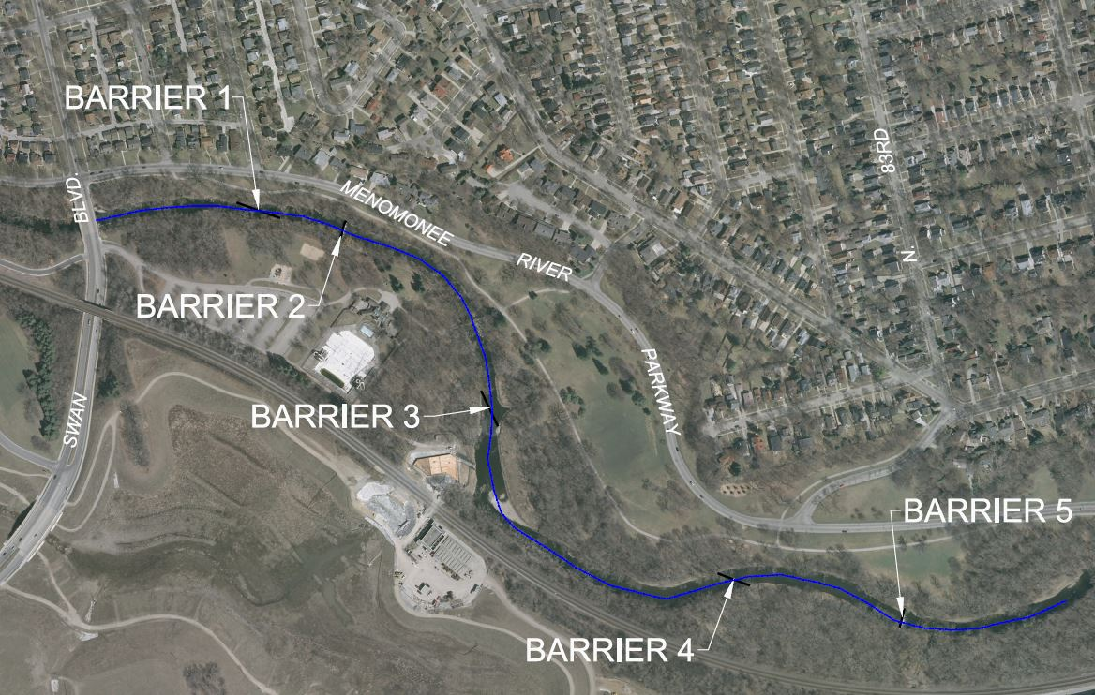

Stakeholders
A stakeholder group was organized to represent the interests of the following organizations, in addition to the District, in the project area:

City of Wauwatosa
Friends of Hoyt Park Pool
Milwaukee County Parks
Milwaukee County Facilities Management
Milwaukee Riverkeeper
Southeastern Wisconsin Regional Planning Commission
Wisconsin Department of Natural Resources

- Was the project completed as originally intended? If not, indicate how the final outcome(s) differed from what was anticipated. Does your experience suggest that original expectations were realistic? What factors hindered or helped progress?

The project met all of the goals as intended for this project.
- The project removed barriers 1, 2 4 and 5 and modified barrier 3 to restore natural stream channel function to provide for fish passage under all flow conditions.
- The project maintained sanitary sewer service to the Hoyt Park Pool facility.
- The project properly abandon approximately 2700 linear feet of 24 inch MIS.
- The project restored 100 linear feet of channel bank that was being eroded due to barrier five.

The expectations and objectives for this project had been vetted over many years of meeting with Menomonee river Watershed stakeholder group. The major drawback was funding. This grant as well as other obtained for this project made it a reality. The project was well received at the two public meetings held to discuss it and the primary criticism was that the project time it took to get it completed.

The only factors that hindered the project were the high bid received during the initial bid process for construction contracts. This precipitated a rebid and delayed construction start by 4 months.
Outcomes
- What activities were pursued in relation to intended outcomes, and to what extent did you achieve the following intended outcomes listed in your proposal?
The stakeholders and MMSD executed the project in compliance with this and four other grants and fully achieved all the outcomes listed in our proposal.
- What audience(s) were you particularly hopeful of reaching? To what extent did you reach them? Did you receive any feedback?
The primary audience was the Menomonee River Watershed Management Plan Stakeholders. Six stakeholder meetings and two public meetings were held in conjunction with this project. The project received positive feedback at all meetings. Primary concerns were keeping the pool facility and beer garden adjacent to two of the barrier locations operational.
- What relationships or opportunities were developed or strengthened through the work?
The stakeholder group that was organized to implement the project, in addition to the District, had worked together on numerous other project from the Menomonee river Watershed Management Plan. The stake holder primary players are listed below.

City of Wauwatosa
Friends of Hoyt Park Pool
Milwaukee County Parks
Milwaukee County Facilities Management
Milwaukee Riverkeeper
Southeastern Wisconsin Regional Planning Commission
Wisconsin Department of Natural Resources
- Was an evaluation included as part of this project? If so, what were the key findings? (Please attach a copy of the evaluation report).
No evaluation was done on this project.
- Whether they were intended or unintended, what do you consider the most important benefits or outcomes of this habitat restoration project?
The most important benefit of this project is that it removed the last major barriers to fish passage in the Menomonee River. The Menomonee River is connected to the Milwaukee Harbor and the Milwaukee Estuary Area of Concern AOC with impacted fish communities and fish habitat impairments. The project improved fish passage for over 39 fish species to over 34 miles river habitat within Menomonee River watershed. The project improved habitat and spawning access for the target species, Northern Pike, as well as the threatened species Greater Redhorse Sucker, three other species of Redhorse sucker, Walleye, Lake Sturgeon, Small Mouth Bass, and several species of native and non-native anadramous and potadramous fish (including salmonid and trout species) migrating up from Lake Michigan.
Related Efforts
- Was this project a standalone effort, or was there a broader effort beyond the part funded by the GLFT? Have other funders been involved, either during the time of your GLFT grant or subsequently?

This project was the only project funded by the GLFT on the Menomonee Rive in partnership with MMSD. However the project and its associated objectives were developed based on the MMSD’s watercourse policies, and the Menomonee river Watershed Management Plan that has been under development starting in 1998. The project builds upon the Menomonee River Watershed River Rehabilitation and Flood Risk Reduction projects developed in the plan. The projects are listed below;.

- Drop Structure Removal immediately upstream of this project (completed in 2000)
- Valley Park Floodwall Project (completed in 2001)
- Hawley Road Bridge Removal Project (completed in 2006)
- Hart Park Flood Management Project (completed in 2006)
- Western Milwaukee Phase I Flood Management Project (completed in 2010)
- Milwaukee County Grounds Floodwater Management Facility (completed in 2011)
- Western Milwaukee Phase 2A Flood Management Project (completed in 2016)
- Menomonee River Stream Management (completed in 2016)

- Has there been any spinoff or follow-up work related to this project? Did this work inspire subsequent, related restoration projects involving you or others?

This project removed the last major manmade impediments in the Menomonee river. Future project will be focused on improving water quality and habitat within the Menomonee River watershed. Particular focus will be on stormwater water quality improvements and upstream spawning habitat to improve the fish communities in the Menomonee river and with the Milwaukee Estuary AOC.
Communication/Dissemination
- List publications, presentations, websites, and other forms of formal dissemination of the project deliverables, tools, or results, including those that are planned or in process.
This project was mentioned on the MMSD web site MMSD.com in our Watercourse Section. There was an article in the Milwaukee Journal Sentinel on the project as well, information on the article is below: aukee Metropolitan Sewerage District
Article title: The Milwaukee Metropolitan Sewerage District plans to remove this limestone dam on the Menomonee River near Hart Park in Wauwatosa. It was built in the 1930s by the Works Progress Administration. By Don Behm of the Journal Sentinel Sept. 14, 2015

Future activities are being considered to hold a “Salmon Festival” in the fall of 2016 in Hart Park, in the City of Wauwatosa, WI, near the project site The festival is being considered to celebrate the salmon run in the Menomonee River which before the completion of this project and others downstream did not get this far upstream.

- Please characterize your efforts to distribute and encourage use of products, processes, programs, etc. developed through this grant.

This project continued activities already being promoted by the Milwaukee Estuary AOC Committee and Menomonee river Watershed Management Plan Stakeholder group.
Reflections
- Please describe any unanticipated benefits, challenges or surprises, and/or important lessons learned over the course of the project.
The greatest challenge was the single bid received during the initial bid process and the resultant rebid delaying the project 4 months.
- What recommendations (if any) would you make to other project directors working on similar efforts or to the GLFT?
This project was mentioned on the MMSD web site MMSD.com in our Watercourse Section. There was an article in the Milwaukee Journal Sentinel on the project as well, information on the article is below: aukee Metropolitan Sewerage District
Article title: The Milwaukee Metropolitan Sewerage District plans to remove this limestone dam on the Menomonee River near Hart Park in Wauwatosa. It was built in the 1930s by the Works Progress Administration. By Don Behm of the Journal Sentinel
Sept. 14, 2015

Future activities are being considered to hold a “Salmon Festival” in the fall of 2016 in Hart Park, in the City of Wauwatosa, WI, near the project site The festival is being considered to celebrate the salmon run in the Menomonee River which before the completion of this project and others downstream did not get this far upstream.

